**ORPHANAGE MANAGEMENT INFORMATION SYSTEM**

A System Proposal presented to the

Faculty of the College of Computer and Information Sciences,

Polytechnic University of the Philippines, Sta. Mesa, Manila

In partial fulfillment for the course

INTE 3043 – Systems Analysis and Design

Castillo, Maricar P.

Garcia, Thomas Jullian R.

Reyes, Jazmine E.

Tagara, Angelica F.

***Proponents***

**March, 2018**

**Table of Contents**

**Chapter 1 – Introduction** 5

**1.1.** **Project Context** 5

**1.2.** **Technical Background** 5

1.2.1. Equipment/Hardware 5

1.2.2. Software 6

1.2.3. Peopleware/Manpower 6

1.2.4. Network Infrastructure/Architecture 7

1.2.5. Storage, Backup and Recovery Procedure 7

1.2.6. Security Procedures 7

1.2.7. Policies and Procedures 8

1.2.8. Data and Process 9

**1.3.** **Problem Analysis** 10

1.3.1. Fishbone Diagram 10

1.3.2. Problem and Solution Statement 12

1.3.3. Problem – Requirements Matrix 12

**1.4.** **Purpose and Description** 14

**1.5.** **Specific Objectives** 15

**1.6.** **Scope and Limitations** 15

**Chapter 2 – Review of Related Literature/Systems** 17

**Chapter 3 – Methodology** 22

**3.1.** **Requirements Analysis** 22

3.1.1. Requirements – Features Matrix 22

3.1.2. Use Case Diagram 24

3.1.3. Use Case Report 26

**3.2.** **Design Specifications** 38

3.2.1. Activity Diagram 38

3.2.2. GUI Design 48

3.2.3. Database Schema 72

**References** 74

**Appendices** 75

**LIST OF FIGURES, TABLES, AND NOTATIONS**

**TABLES**

**Table 1: problem – REquirements Matrix** **Error! Bookmark not defined.**

**TABLE 2: REQUIREMENTS – FEATURES MATRIX** **Error! Bookmark not defined.**

**TABLE 3: USE CASE REPORT** **Error! Bookmark not defined.**

Table 3.1: Login Use Case Report **Error! Bookmark not defined.**

Table 3.2: Manage Client Applications Use Case Report **Error! Bookmark not defined.**

Table 3.3: Manage Orphanage Assets Use Case Report **Error! Bookmark not defined.**

Table 3.4: Manage Scholar Records Use Case Report **Error! Bookmark not defined.**

Table 3.5: Manage Orphan Records Use Case Report **Error! Bookmark not defined.**

Table 3.6: Submit Application Forms Use Case Report **Error! Bookmark not defined.**

Table 3.7: Manage Scholar Budget Use Case Report **Error! Bookmark not defined.**

Table 3.8: Generate Reports Use Case Report **Error! Bookmark not defined.**

Table 3.9: Refer Orphans Use Case Report **Error! Bookmark not defined.**

Table 3.10: Refer Orphans Use Case Report **Error! Bookmark not defined.**

**FIGURES**

**FIGURE 1: FISHBONE DIAGRAM 1** **Error! Bookmark not defined.**

**FIGURE 2: FISHBONE DIAGRAM 2** **Error! Bookmark not defined.**

**FIGURE 3: USE CASE DIAGRAM** **Error! Bookmark not defined.**

Figure 3.1: Manage Orphanage Assets Use Case Sub-Diagram **Error! Bookmark not defined.**

Figure 3.2:Manage Orphan Records Use Case Sub-Diagram **Error! Bookmark not defined.**

Figure 3.3: Manage Scholar Records Use Case Sub-Diagram **Error! Bookmark not defined.**

**FIGURE 4: ACTIVITY DIAGRAM** **Error! Bookmark not defined.**

Figure 4.1: Login Activity Diagram **Error! Bookmark not defined.**

Figure 4.2: Manage Client Applications Activity Diagram **Error! Bookmark not defined.**

Figure 4.3: Manage Orphanage Assets Activity Diagram **Error! Bookmark not defined.**

Figure 4.4: Manage Scholar Records Activity Diagram **Error! Bookmark not defined.**

Figure 4.5: Manage Orphan Records Activity Diagram **Error! Bookmark not defined.**

Figure 4.6: Submit Application Forms Activity Diagram **Error! Bookmark not defined.**

Figure 4.7: Manage Scholar Budget Activity Diagram **Error! Bookmark not defined.**

Figure 4.8: Generate Reports Activity Diagram **Error! Bookmark not defined.**

Figure 4.9: Refer Orphans Activity Diagram **Error! Bookmark not defined.**

Figure 4.9: Refer Orphans Activity Diagram **Error! Bookmark not defined.**

# 

# **Chapter 1 – Introduction**

* 1. **Project Context**

Concordia Children’s Services is a child welfare agency that provides both residential and community based programs. They take in orphans and assist children who are from very poor families and provide them with education, spiritual hope and nourishment. It was founded in 1983, in partnership with another child caring agency for abandoned, neglected and orphaned children.

Concordia Children’s Services offers two main programs: (1) Educational Assistance thru Sponsorship and (2) Receiving Home Program. The educational assistance thru scholarship, also known as, Edward A. Strohchein program, assists children, age 7 to 16 years old, whose families cannot fully support their education. The program has the following services: Educational Assistance, Sports and Recreation, Social Services, Christian Education, Feeding Program, Spiritual Services, and Family Services.

The Receiving Home Program aims to raise and care for abandoned, neglected, surrendered and orphaned children in a loving Christian and Filipino Culture based environment. The Receiving Home program utilizes a holistic approach through its different services. The program has the following services: Home Life Services, Recreational Services, Volunteer Services, Health and Nutrition, Spiritual Services, and Social Services.

* 1. **Technical Background**
     1. Equipment/Hardware

There are a total of fourteen computers in the orphanage. The six are used for research in the Resource Development Center while the remaining eight are used in the office of employees. These computers are all running on Windows 7 except for a single computer running Windows 10 in the employee office. Printers are also used by the people in the orphanage. There are a total of five printers – two in the Resource Development Center and the rest are in the office for employees. Aside from these, there is also a single Skywork television in the Resource Development Center.

* + 1. Software

The main software suite used by the employees and the people who use the Resource Development Center in the orphanage is the Microsoft Office. They usually use Microsoft Excel and Microsoft Word. They also use standard browsers such as Google Chrome, Mozilla Firefox and Internet Explorer. The accountant uses a software called Quickbook – an accounting software that monitors payments and payroll functions. The staff uses an online database called Akubo which manages the monetary donations and stores donor information.

* + 1. Peopleware/Manpower

The board of trustees has the founder and board adviser, and is led by the chairman. Under the chairman is the vice-chairman, secretary, and its three members. The orphanage is led by the executive director. Under him is the program supervisor of the Receiving Home Program, program supervisor of the educational assistance thru scholarship program, the Resource Development Program and the accountant. Under the Receiving Home Program are the resident nurse, maintenance staff, laundress, and seven caregivers. Under the Educational Assistance thru Scholarship Program is the community development officer. Under the Resource Development Program are the resource development officer and the volunteers. Lastly, under the accountant is the admin and finance officer.

* + 1. Network Infrastructure/Architecture

The network architecture used is a server – client architecture for both the Resource Development Center and the office for the employees. The five computers in the Resource Development Center are connected to a single computer as a server through a router and connected to a modem for internet. The seven computers in the employee office are connected to a single computer as a server through a router and connected to a modem for internet.

* + 1. Storage, Backup and Recovery Procedure

Some of the data managed by the orphanage employees are stored in their own computers depending on who handles which data. Physical files are also kept by the employees especially by the receiving home program and educational assistance thru scholarship program. These physical files are kept in a filing cabinet labeled with “Confidential Files” tag and “For Authorized Employees” tag.

The employees have no standard procedure for data backup. The backup schedule depends on the employees and usually done at random times and is stored in an external hard drive. The backup procedures varies per employees but some employees usually delete what they think are unnecessary files before proceeding with the backup. The employees also have no plan for recovery because it has not happened before.

* + 1. Security Procedures

The security they have for their automated data is their password protected computers. The physical files are stored in a filing cabinet labeled with “Confidential Files” tag and “For Authorized Employees” tag. This filing cabinet is closed by a lock and placed in a secure location. There is also no training for staff regarding data security and other security procedures.

* + 1. Policies and Procedures

In the receiving home program, a child will be referred to the orphanage either by a social worker from the hospital where a child was found or the city government social worker. Once accepted, the orphanage will receive the case study and documents of child. If the child does not have the necessary documents, the orphanage will provide these legal documents for them. They will also create a case study that will monitor the child's growth until they are ready for adoption. If the orphanage cannot accept more orphans, they will refer the child to another orphanage.

Once a child reaches the suitable age for adoption, the orphanage will submit an application for adoption to the DSWD stating that the child is ready for adoption. The staff-in-charge will present the child's case study to the DSWD. The DSWD would then find a suitable adopter that will match the child's behavior and personality. After finding a suitable match, the orphanage would allow a 3-day visitation before the adopter takes custody of the child. The documents would be passed to a social worker assigned to monitor the adopter and the child's progress in the family.

In the educational assistance thru scholarship program, a scholar may apply or be referred by people in the orphanage. Once a scholar is accepted, the orphanage will find a sponsor for the child. The sponsor will provide monetary funds for the scholar and has the right to decide whether to terminate his sponsorship. The orphanage sends mid-year and year end reports to the scholar's sponsor. They also require the scholar to attend weekly tutoring sessions, bible study lessons and other activities.

* + 1. Data and Process

The orphanage manages the data of the orphans, scholars including their sponsors and donors. The orphanage accepts orphans through the referral of social workers. These social workers submit child's birth certificate and medical report, case study and referral letter to the orphanage and the staff reviews these before determining whether to accept the child or refer it to another orphanage. The staff confirms if the child matches the requirements of the orphanage and they send their confirmation after. Once the staff for receiving home receives the basic information of the orphans, they provide the necessary requirements and create a case study regarding the child’s life. If a child is ready for adoption, they submit the child’s petition and application, case study and birth certificate, proof of efforts to locate child's relatives, and deed of voluntary commitment.to the DSWD. The government agency would be the one to find a suitable family for the child. Once the DSWD have found the family that would match the child, they would send the details of the adopter to the orphanage. In the educational assistance thru scholarship program, a scholar may apply by submitting his/her report card, birth certificate and application form. Once the staff has accepted and confirmed the child's application, they create a case study for that child. They accept sponsors by reviewing their submitted applications. Once a scholar has been assigned to a sponsor they send the introductory letter and child profile, and child correspondence. The staff sends mid-year and annual progress reports and the letters of the children in order to update the sponsor of the child's progress. They also manage the data of the donors as well as the in-kind or cash donation given and it is up to the donors if they want to give their personal information. For both the sponsor and donor, the orphanage provides them with a receipt after having received the donations.

* 1. **Problem Analysis**
     1. 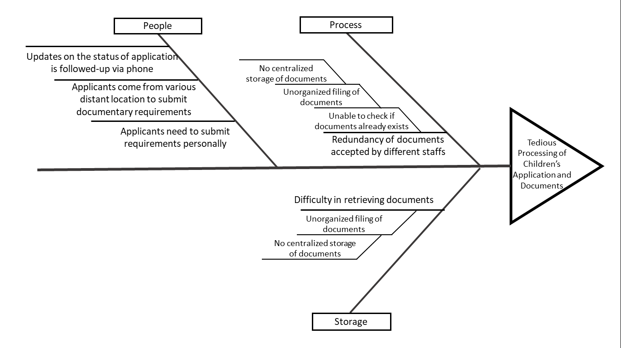Fishbone Diagram

*Figure 1: Fishbone 1 (Tedious Processing of Children’s Applications and Documents)*

The orphanage encounters different problems when it comes to processing different documents. Because they lack centralized storage of documents, the filing of documents is unorganized and makes it difficult for them in retrieving documents. The lack of centralized storage and the unorganized filing of documents also cause them to not be able to check whether a specific document already exists or not. This problem then results to redundancy of documents accepted by different staffs. Apart from the problems encountered by the orphanage, clients encounter problems, too. Applicants are required to submit applications forms and requirements personally. This is a problem for applicants who come from various distant location as they need to go back and forth to submit documentary requirements. All these problems lead to tedious processing of children’s application and documents.

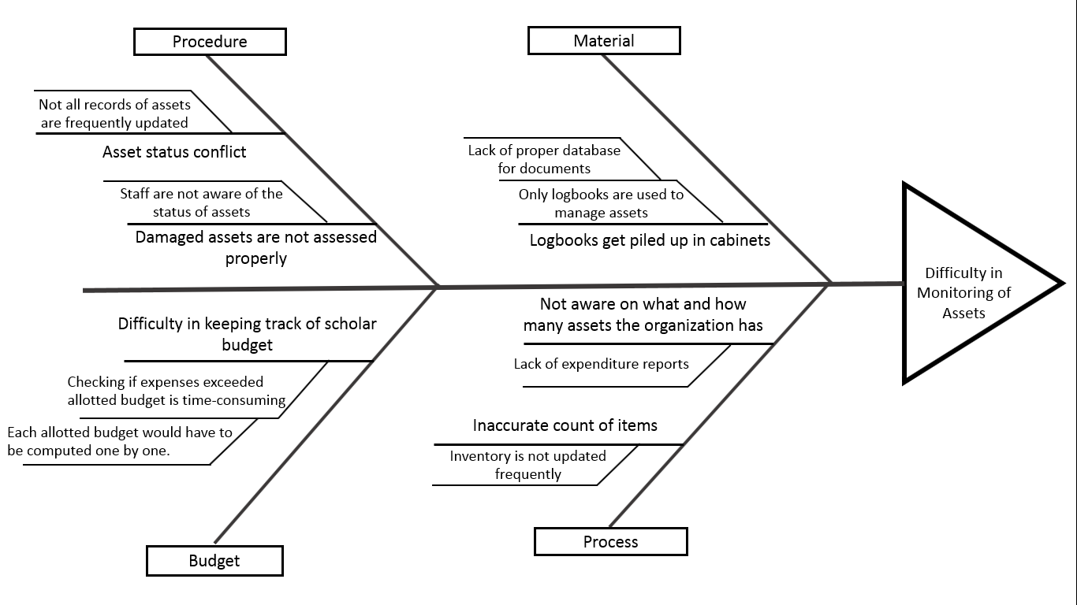

*Figure 2: Fishbone 2 (Difficulty in Monitoring of Assets)*

Along with the records of orphans and scholars, they also deal with the records of assets of the orphanage. There are cases where damaged assets are not assessed properly because of staffs not being aware of the asset status. Conflicts’ regarding asset status occurs because not all records of assets are updated frequently. As records increase, logbooks, where the records are written, get piled up in cabinets. These logbooks are the only database they used for managing assets. This shows that they lack an efficient database for asset records storage. In the budget category, difficulty in keeping track of scholar budget is due to the time consuming checking of expenses. This process is time consuming because each allotted budget would have to be computed and compared to the expenses. Because of these problems, it will result to the difficulty in monitoring of assets.

* + 1. Problem and Solution Statement

The Concordia Children’s Services, Inc., deals with processing tons of records of orphan, scholars, and even assets. Based on our fishbone, we were able to identify and sum up the different problems that lead to tedious processing of children application and documents and the difficulty in monitoring assets. The problems of the orphanage are the lack of secured, centralized, and organized storage of documents, the lack of facility or medium for interaction with distant clients, and the lack of efficient inventory system. These problems can be solved by a web-based management information system that will have a secured, centralized, and organized storage of documents and an automated inventory management system. The web-based system will address the lack of facility or medium as it will become a medium between distant clients and the orphanage.

* + 1. Problem – Requirements Matrix

*Table 1: Problem-Requirements Matrix*

|  |  |  |
| --- | --- | --- |
| **ID** | **PROBLEM** | **REQUIREMENT** |
| PR1 | No centralized storage of documents | Provide central storage of documents |
| PR2 | Redundancy of documents accepted by different staff | Provide access control to the different staff in order for them to view applications |
| PR3 | Difficulty in retrieving documents | Provide a way to query and search for specific records |
| PR4 | Unorganized filing of documents | Allow documents and records to be sorted according to staff preference |
| PR5 | Applicants come from various distant location to submit documentary requirements | Provide a web platform for an alternate way in submitting document requirements |
| PR6 | Applicants need to submit requirements personally | Provide a web platform for submitting application for scholarship and sponsorship |
| PR7 | Only logbooks are used to managing assets | Provide a module for managing assets |
| PR8 | Asset status conflicts | Provide a way for updating asset status and notifying staff on status |
| PR9 | Updates on the status of application is followed-up via phone | Provide a way for applicants to view the progress of their application |
| PR10 | Inaccurate count of items | Provide a way for updating count of each asset of the orphanage |
| PR11 | Each allotted budget would have to be computed one by one | Provide a feature that will manage and monitor every scholar expense |

The problem of no centralized storage is solved by providing a centralized storage of documents which would store all records of scholars, orphans and assets. Redundancy of documents accepted by different staff will be solved by providing access control to the different staff in order for them to view applications. This would allow different staffs to view all applications and see those that have been already approved. Difficulty in retrieving documents will be solved by providing a way to query and search for specific records which would allow the staff to find a specific document that they need. Unorganized filing of documents will be solved by allowing documents and records to be sorted according to staff preference. Applicants coming from various distant locations to submit documentary requirements and applicants needing to submit requirements personally will be solved by providing a web platform for an alternate way in submitting documentary requirements and applications for sponsorship and scholarship. This would provide an easier way of submitting applications and lessen the hassle for each client. Using logbooks to managing assets will be solved by providing a module for managing assets. This would allow the staff to monitor the assets of the scholars and the orphanage. Asset status conflicts will be solved by providing a way for updating asset status and notifying staff on status. Updates on the status of application are followed-up via phone will be solved by providing a way for applicants to view the progress of their application. Applicants will be able to monitor their applications personally by allowing them to view the status of their applications online. Inaccurate count of items will be solved by providing a way for updating count of each asset of the orphanage. This would allow the staff of the orphanage to update the count and status of each asset in case of error in input. Lastly, the problem of each allotted budget would have to be computed one by one will be solved by providing a feature that will manage and monitor every scholar expense and compare it with the allotted budget.

* 1. **Purpose and Description**

The purpose of the project is to propose a solution to the problem of tedious processing of children's application and requirements and difficulty in monitoring assets. The main purpose of the system is to create software where all the process they use is accumulated into one system. This will support all records that used to be handwritten, noted in papers and kept in folders and cabinets which are prone to damage or fade away over time. We aim to secure all the data and information they have not only for them but also for their client. The goal of our system is to lessen the load with the paperwork and fasten the process of the orphanage.

We also aim to provide a platform that will allow the clients to easily access forms instead of handing documents personally. So, we came up proposing a web-based management information system that will manage the records in the orphanage (orphans, scholars and asset) and have all documents to be stored in a secured database instead of storing them in logbooks, folders and cabinets. The compilation of documents will be automated to make it easier for the orphanage to monitor and search documents, and even generate reports from these.

The system will also support features such as application processing and monitoring, asset and expense monitoring, orphan and scholar information system and budget monitoring system.

The budget monitoring system will help them in monitoring their every scholars expense. This can help the orphanage in planning how much budget to allocate in a certain category of expenses. The goal of the budget system is to help them to budget the money given by the sponsor properly based on the money input and time frame.

* 1. **Specific Objectives**

1. To enumerate the problems encountered in the current system or current processes in the Educational Assistance thru Scholarship program and Receiving Home program in Concordia Children Services, Inc.
2. To evaluate the existing processes of orphan and scholar intake in the orphanage.
3. To propose a management information system that addresses the problem of tedious processing of children’s applications and documents, and the problem of difficulty in monitoring assets.
4. To identify the requirements of the proposed management information system.
5. To design a system that would include an information system for scholars and orphans, an asset management system for the orphanage along with a budget system for scholars, and an application monitoring system.
   1. **Scope and Limitations**

This study will focus on developing a web-based orphanage management information system that will cover an information system for managing the documents of orphans, scholars and their case studies. It will cover a budget monitoring system for managing the allotted budget for specific expenses of each scholar such as transportation, school supplies, school uniform, projects and other school contributions. It will also cover asset management for monitoring item inventory and supplies and an application monitoring system for application forms that are submitted to Concordia Children’s Services, Inc., an orphanage that is located in Sta. Mesa, Manila.

This study will not cover the transactions involving monetary donations received by the orphanage. The management of application forms will only be limited to monitoring scholarship, sponsorship and orphan referral application forms. This study will not focus on the adoption process in the orphanage.

All records that are gathered and will be gathered in this study will only be coming from the Concordia Children’s Services, Inc., specifically from staffs, admins, and their clients.

# **Chapter 2 – Review of Related Literature/Systems**

An orphanage is a home for children whose parents are deceased or are unable to care for them. It is an institution that provides service to the children in need of care and shelter to live in (Cambridge Dictionary, n.d.). A massive amount of data is being used such as the data of orphans and in transactions that take place in the orphanage.

Shreya Krishnam (2016) noticed that in an orphanage she visited, transactions and data storage were done manually, making it very tedious to organize, store and retrieve data. She therefore developed an orphanage management system using C++ and object-oriented concepts that allows data to be gathered in a single database thus making transactions more efficient.

We have searched several kinds of Scholarship systems and one of the systems that we've found allows children in need to have monetary support in order to finish their studies. A scholarship management system by Eric Irvin Sauser (2011), it contains functionalities for four primary actions on five sets of data. The primary actions are adding, deleting and viewing of data while the sets of data are scholarship, administrative units, authorizing agents, applicants and award. This system has no user authentication thus real users cannot be distinguished from fake ones.

The scholarship information system that we've found allows the user to easily maintain the data without any loss or damage. The users of this system, the Scholarship Officers, can easily check the eligible criteria of every student, the user can easily generate the record of students who are eligible for the scholarship. The system is developed for scholarship departments of a group of colleges. It is because majority of the students are not aware of the various schemes of scholarship applicable to them. In order for the students to have a general awareness, the developer came up with an idea that each and every educational institution should take active participation in the implementation of various scholarship schemes under their supervision. During application period, the scholarship officers can add data regarding student information e.g. student's parent's income.

In the orphan and scholar information system, the staff would create a case study for each scholar and orphan. The system would provide a way for the staff to add a case study. After adding, this would be saved in cloud storage and will be downloaded onto the staff’s computer (Rouse, 2016). Cloud storage is a service model which data is maintained, managed, backed up remotely and made available to use over a network. There are three main cloud-based storage architecture models, one of those is Public Cloud, it is a storage service provide a multi-tenant storage environment that is most suited for unstructured data, next is the Private cloud, private clouds are appropriate for users who need customization and more control over their data, last is the Hybrid Cloud, it is a mix of Public and Private Cloud service with orchestration between the platforms for management (Mitchell, 2017). We would incorporate private cloud in our storage and it will serve as a backup for the files of case study.

Assets are an important part of an organization. Assets are defined as resources owned by a company or an individual e.g. cash, inventory and land. In a study developed by Noor Hartini Binti Shamshudin (2012), student from University of Malaysia, he created a system to automate the transactions of staff in getting whatever item they need from the school. Initially, log books where being used but this has become a burden for the staff so he created a system that would allow the staff to keep track of the assets of the school. He developed this system using HTML, PHP and JavaScript. The system interacts with a database using Server Query Language. The objective of his system is to develop a based system computerized School Asset Management System for Sekolah Kebangsaan USJ20.

Part of the assets that the orphanage manages is the inflow and outflow of cash to the scholars from the sponsors. In order to adequately disburse the amount allotted for a specific purpose and to make sure it lasts for the whole school year a budget monitoring system is proposed to be added in the expense management of the scholars. A mobile application for daily budgeting and expense monitoring was developed by Cedric Calapatia (2014) et al called BMA or Budget Monitoring App. This proposed system allows for allocation of expenditures, setting the user’s desired saving amount, debt management and generation of reports.

We have also found an application that helps users plan their budget more efficiently. This application is named “Budget planner” and created by two developers, Bindu Madhavi K Khambam and Suganya Srinivasan (2015) from California State University - Sacramento. The objective of their system is to help the user to plan, monitor and control their finances. This application focuses on the expenditures that are more important for the user. Once the user entered their expenses they could set reminder alerts when they’re due and mark when they have been paid. They could also allot budgets per category. The application is suitable for tracing income and expense in order to have a balanced and well-organized financial report. The researchers could use the Budget Planner as a basis for their budget monitoring. The proposed management information system will have a way to budget the allotted monetary fund for a scholar. Just like the above application, the proposed system would allow the staff to allot a budget for every expense category. This would be useful in case a scholar needed more money and the staff can assess which allotted budget may be used in order to provide what the scholar needed.

From the systems we have reviewed, some systems have functions that our proposed system does not have. First, is the function of relating to scholar tuition. Second is the viewing of enrollment details of scholars in which the staff can search the data of orphans, delete the data of the orphan and their enrollment, edit the changes of the enrollment and save it as updated data. Lastly, functions relating to adoption, such as allowing the staff to add the details about the new adopter. The new adopter may be a person or a family. Our system does not have these functions because it is not applicable to the process of our client.

Some orphanage management systems have incomplete functions and they only provide storage of data which can be easily done by a relational database management system. In order to improve these studies, our system will provide submission of the client-side application forms, such as the scholarship form, sponsorship form, and donor application form. They need to fill up the required information in order to successfully send it to the database of the organization and the assigned personnel will be able to process it. This will allow data to be stored in a central storage and easily viewed by the personnel. It will also allow potential scholars, sponsors and donors to easily access application forms. Compared to other scholarship systems, the system we have proposed will allow the orphanage staff to monitor the health of their scholars. This will also allow the staff to manage orphanage assets.

After having assessed and reviewed other systems, we have based a subsystem of our proposed solution, the orphan and scholar information system, to the orphanage management system created by Shreya Krishnam. She only addressed the manual process of the orphanage in order to provide an easier way of managing administrative functions. This helped us formulate a solution that would focus not only on the manual process of our client but also on other problems. We have used her idea as the foundation of our system by developing centralized database that allows data to be gathered in a single database thus making transactions more efficient. Based on the idea of the asset management by Noor, because our client also has a problem with the process and monitoring of their assets we could also create a system to automate the transaction of the staff in getting whatever item they need from the orphanage for the orphans and for the scholars. Aside from automating transactions, we have added a way to generate reports for the transaction of the staffs so that when they need a hardcopy for the item that they enlist they could print it quickly and easily.

In continuation of our research, we have come up to an idea that we would create a solution to the problem of tedious processing of children application and the problem in monitoring of their assets. The purpose of this solution is to create a platform where all the process of the orphanage is accumulated into one system. Instead of writing all of the requirements in the specific form like sponsorship form, scholarship form the user will fill up the required information in web based application form, where all the form they need is in there. Even when they are in distant location they can send it in the admin of the orphanage by using the system. The user could also donate for the children's needs. They just also need to fill up the requirements. We also added budget monitoring system. This feature is for the staff of the scholarship program of the orphanage so that they can manage the expenses of each scholar they are handling. The staff could send the monitored expense of the scholar to the sponsor of the scholar. We could use the Budget Monitoring App as a basis for our budget monitoring. Having a balanced allowance every week for children would be difficult for the admin of the orphanage because they could not know if the scholar needs a higher amount of money and it is difficult to allot a specific amount especially if the child suddenly needed more.

# **Chapter 3 – Methodology**

* 1. **Requirements Analysis** 
     1. Requirements – Features Matrix

*Table 2: Requirements-Features Matrix*

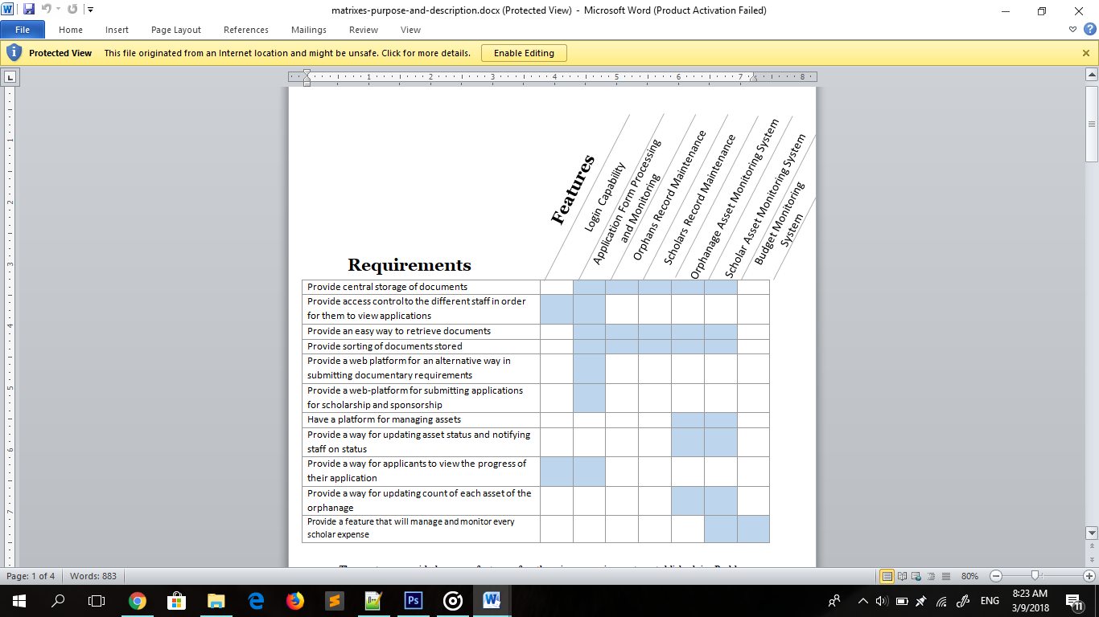

The system would provide seven features for the given requirements established in Problem-Requirements Matrix: (1) Login Capability, (2) Application Form Processing and Monitoring, (3) Orphans Records Maintenance, (4) Scholar Records Maintenance, (5) Orphanage Asset Monitoring System, (6) Scholar Asset Monitoring System and (7) Budget Monitoring System.

Provide central storage for documents has the features of Application Form Processing and Monitoring, Orphans Records Maintenance and Scholar Records Maintenance that will uphold the processed application and documents. Providing access control to the different staff in order for them to view applications requires a feature of login capability and application form processing and monitoring while providing easy way to retrieve documents will cover the feature of login capability and orphanage asset monitoring system. In providing sorting of stored documents requires application form processing and monitoring, orphans and scholars’ maintenance and orphanage and scholar asset monitoring system. To provide a web-platform for an alternative way in submitting documentary requirements and for submitting application for scholarship and sponsorship, the system offer the feature of application form processing and monitoring.

Orphanage and scholar asset monitoring lets the feature of the system, orphanage and scholar asset monitoring system, to have a platform for managing, updating and notifying the staff on assets. Also, to provide way for updating to view the progress of their application, the system has the feature of application form processing and monitoring. In addition, the requirement providing a way for updating count of each asset of the orphanage lets the orphanage and scholar asset monitoring system handle it. Lastly, to monitor and manage the scholar expense, the system will provide a feature under Budget Monitoring System.

* + 1. Use Case Diagram

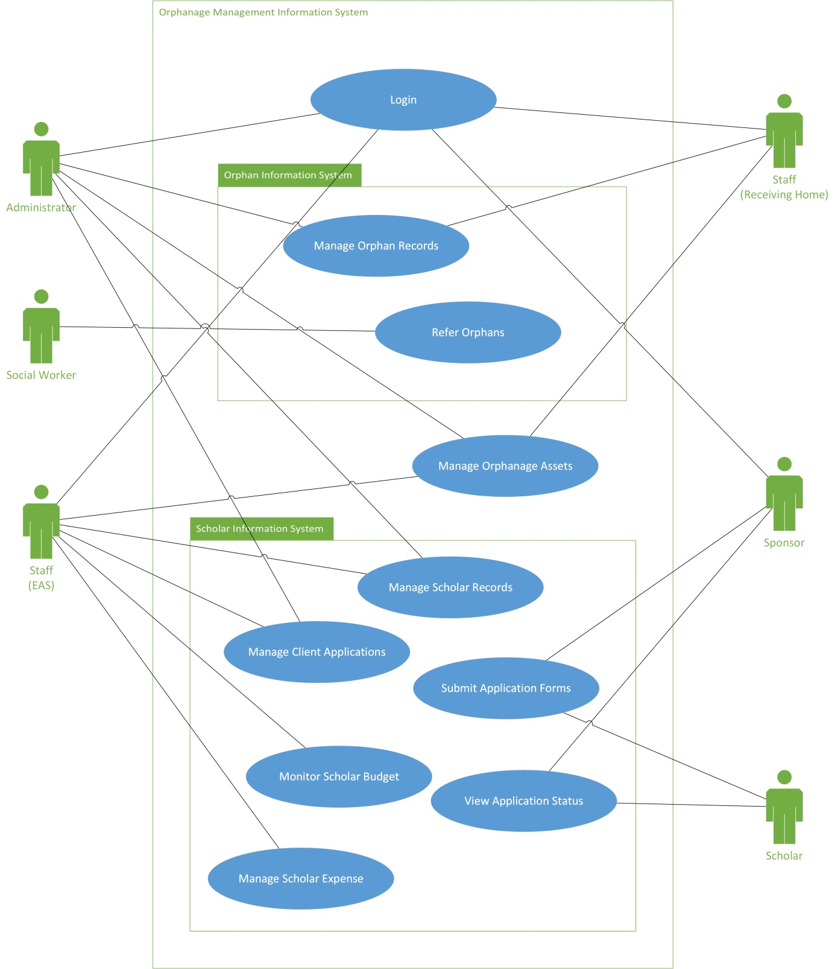

*Figure 3: Orphanage Management Information System Use Case Diagram*

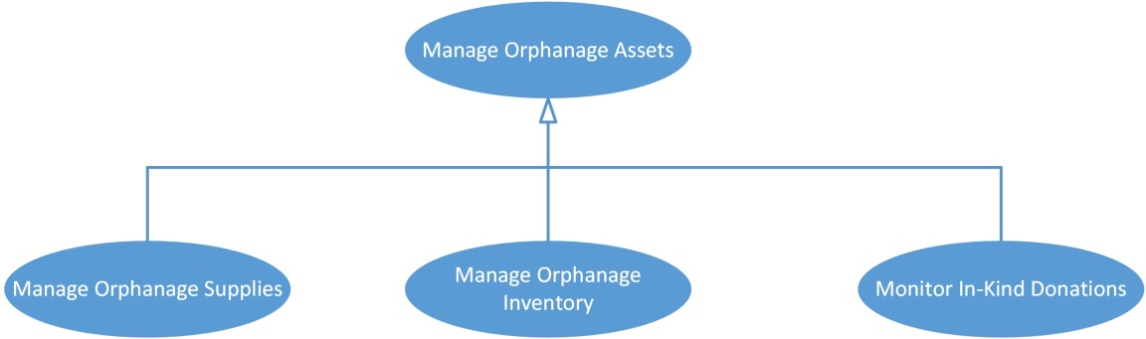

*Figure 3.1: Manage Orphanage Assets Use Case Sub-Diagram*

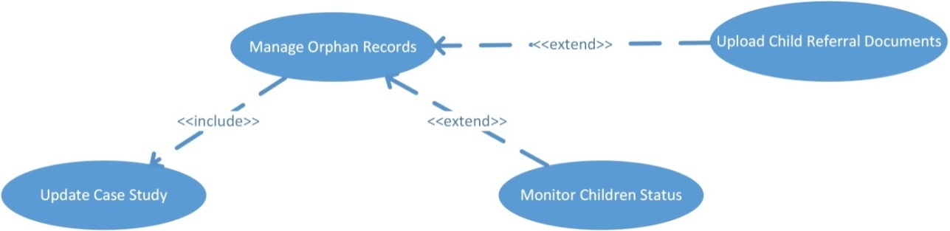

*Figure 3.2: Manage Orphan Records Use Case Sub-Diagram*

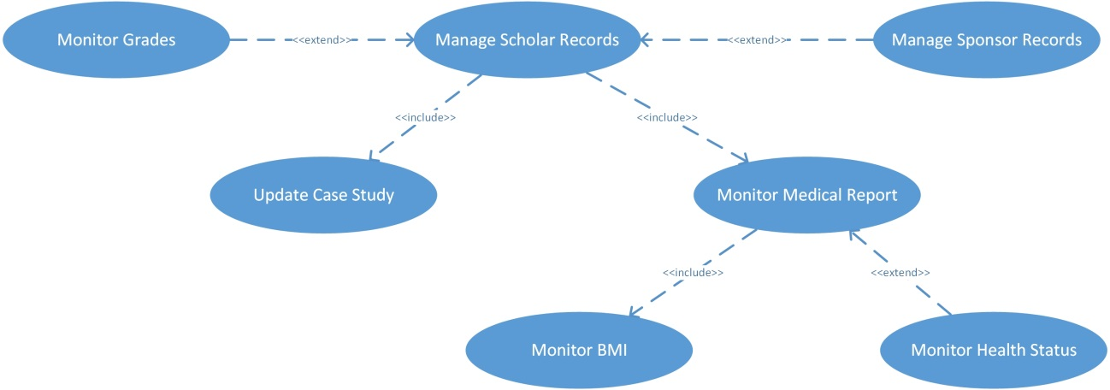

*Figure 3.3: Manage Scholar Records Use Case Sub-Diagram*

* + 1. Use Case Report

*Table 3.1: Login Use Case Report*

|  |  |
| --- | --- |
| Identification | **UC1** |
| Name | Login |
| Actors Involved | Administrator and Staff |
| Brief Description | Allows the individual to access the system by identifying and authenticating themselves. |
| Assumptions | Administrator and Staff have their account. |
| Preconditions | None |
| Postconditions | Administrator or staff has logged in and can access specific modules. |
| Flow of Events | 1. Enter username and password. 2. Click Login. If username or password is incorrect, go to Alternate Flow #1. 3. Login successful. |
| Alternative Flow | 1. Incorrect username and password  * Display error message * Go back to Flow #1. |
| Included Use Cases | None |
| Extended Use Cases | None |

*Table 3.2: Manage Orphan Records Use Case Report*

|  |  |
| --- | --- |
| Identification | **UC2** |
| Name | Manage Orphan Records |
| Actors Involved | Staff (Receiving Home Program) |
| Brief Description | Allows the staff to manage the records of orphans for the well-organized and systematic control of the orphanage. |
| Assumptions | There is a limited number of orphans |
| Preconditions | Staff has already logged in |
| Postconditions | A record has been created or updated |
| Flow of Events | 1. Choose Orphans 2. Choose Action    1. View Orphan List    2. Add an Orphan       1. Enter the required information. If input is incomplete, go to Alternate Flow #1.       2. Save Record.    3. Update an existing record       1. Choose an orphan       2. Enter the required information. If input is incomplete, go to Alternate Flow #1.       3. Save Record.    4. Cast Study       1. Update Case Study       2. Save Case Study |
| Alternative Flow | 1. Incomplete input of information  * The system will notify the user to filled-up the required information. * Go back to flow. |
| Included Use Cases | * Update Case Study |
| Extended Use Cases | * Upload Child Referral Documents * Monitor Children Status |

*Table 3.3: Refer Orphans Use Case Report*

|  |  |
| --- | --- |
| Identification | **UC3** |
| Name | Refer Orphans |
| Actors Involved | Social Worker |
| Brief Description | Allows the social worker to refer a child as an orphan in the orphanage |
| Assumptions | Social worker |
| Preconditions | None |
| Postconditions | A record has been created or updated |
| Flow of Events | 1. Go to website. 2. Click Refer Orphan    1. Enter the required information. If input is incomplete, go to Alternate Flow #1.    2. Send referral letter. |
| Alternative Flow | 1. Incomplete input of information  * The system will notify the user to filled-up the required information.   Go back to flow. |
| Included Use Cases | None |
| Extended Use Cases | None |

*Table 3.4: Manage Orphanage Assets Use Case Report*

|  |  |
| --- | --- |
| Identification | **UC4** |
| Name | Manage Orphanage Assets |
| Actors Involved | Administrator and Staff |
| Brief Description | This allows the administrator and staff to manage the supplies and inventory of the orphans and scholars. |
| Assumptions | * Asset is going to be assessed * A donation is given * Items are going to be released |
| Preconditions | Staff has already logged in |
| Postconditions | Item count has increased or decreased |
| Flow of Events | 1. If Administrator or RH Staff, go to Assets.    1. Choose List       1. View inventory and supplies list.       2. Add new item.       3. Enter the required information. If input is incomplete, go to Alternative Flow #1.       4. Save Record.    2. Choose Assessment       1. Release Item          1. Enter the required information. If input is incomplete, go to Alternative Flow #1.          2. Save Record       2. Assess Item          1. Enter the required information. If input is incomplete, go to Alternative Flow #1.          2. Save Record 2. If EAS Staff, go to Assets.    1. Choose List       1. View supplies list.       2. Add new item.       3. Enter the required information. If input is incomplete, go to Alternative Flow #1.       4. Save Record.    2. Choose Assessment       1. Release Supplies          1. Enter the required information. If input is incomplete, go to Alternative Flow #1.          2. Save Record |
| Alternative Flow | 1. Incomplete input of information  * The system will notify the user to filled-up the required information. * Go back to flow. |
| Included Use Cases | None |
| Extended Use Cases | None |

*Table 3.5: Manage Scholar Records Use Case Report*

|  |  |
| --- | --- |
| Identification | **UC5** |
| Name | Manage Scholar Records |
| Actors Involved | Administrator and Staff (EAS Program) |
| Brief Description | Allows the staff to manage the records of scholars for the well-organized and systematic control of the orphanage. |
| Assumptions | There is a limited number of scholars |
| Preconditions | Staff has already logged in |
| Postconditions | A record has been created or updated |
| Flow of Events | 1. Choose Scholars 2. Choose Action    1. View Scholar List    2. Add a Scholar       1. Enter the required information. If input is incomplete, go to Alternate Flow #1.       2. Save record    3. Update existing record       1. Choose a scholar record       2. Enter the required information. If input is incomplete, go to Alternate Flow #1.       3. Save record    4. View Medical Report       1. View BMI List       2. Add BMI. If input is incomplete, go to Alternative Flow #1.          1. Input height          2. Input weight          3. View BMI          4. Add remarks    5. Case Study       1. Update Case Study       2. Save Case Study.    6. View Academic Report       1. Encode Grades          1. Input grades          2. Display average 3. Choose Sponsors    1. View sponsor list    2. Add a sponsor       1. Enter the required information. If input is incomplete, go to Alternate Flow #1.       2. Save Record.    3. Select Sponsor Record       1. Choose Action          1. Send Scholar Progress          2. Terminate Sponsorship |
| Alternative Flow | 1. Incomplete input of information  * The system will notify the user to filled-up the required information. * Go back to flow. |
| Included Use Cases | * Update Case Study * Monitor Medical Report (extends Monitor BMI and Monitor Health Status) |
| Extended Use Cases | * Monitor Grades * Add Sponsor Records |

|  |  |
| --- | --- |
| Identification | **UC6** |
| Name | Manage Client Applications |
| Actors Involved | Administrator and Staff |
| Brief Description | Allows the individual to manage applications sent in by clients. |
| Assumptions | Client has submitted an application form. |
| Preconditions | The administrator or staff has already logged in. |
| Postconditions | An application is approved or declined. |
| Flow of Events | 1. View pending applications 2. Choose action    1. Approve application    2. Decline application    3. Send e-mail with appointment details |
| Alternative Flow | None |
| Included Use Cases | None |
| Extended Use Cases | None |

*Table 3.6: Manage Client Applications Use Case Report*

*Table 3.7: Submit Application Forms Use Case Report*

|  |  |
| --- | --- |
| Identification | **UC7** |
| Name | Submit Application Forms |
| Actors Involved | Sponsor and Scholar |
| Brief Description | Allows the client to apply as a sponsor, scholar or donor by submitting an application form. |
| Assumptions | Client is a potential scholar, sponsor, or donor |
| Preconditions | None |
| Postconditions | Form is submitted  There will be a pending application |
| Flow of Events | 1. Go to Website 2. Go to Applications 3. Choose a category    1. Fill up the application form    2. Submit form. If input is incomplete, go to Alternate Flow #1. |
| Alternative Flow | 1. Incomplete input of information  * The system will notify the user to filled-up the required information. * Go back to flow. |
| Included Use Cases | None |
| Extended Use Cases | None |

*Table 3.8: Monitor Scholar Budget Use Case Report*

|  |  |
| --- | --- |
| Identification | **UC8** |
| Name | Monitor Scholar Budget |
| Actors Involved | Staff (EAS Program) |
| Brief Description | Allows the staff to manage and monitor every scholar’s money on how much budget to allocate in a certain category of expense |
| Assumptions | Sponsor has already guaranteed the donation for sponsorship |
| Preconditions | None |
| Postconditions | A record has been created or updated |
| Flow of Events | 1. View Scholars List 2. Choose a scholar record    1. Add scholar budget       1. Enter the required information. If input is incomplete, go to Alternate Flow #1.       2. Save budget.    2. View statement of expense       1. Add expense          1. Enter the required information. If input is incomplete, go to Alternate Flow #1.          2. Save expense. |
| Alternative Flow | 1. Incomplete input of information  * The system will notify the user to filled-up the required information. * Go back to flow. |
| Included Use Cases | None |
| Extended Use Cases | None |

*Table 3.9: View Application Status Use Case Report*

|  |  |
| --- | --- |
| Identification | **UC9** |
| Name | View Application Status |
| Actors Involved | Sponsor and Scholar |
| Brief Description | Allows the client to view and know the status of their submitted application. |
| Assumptions | Sponsor or Scholar has submitted an application form. |
| Preconditions | Sponsor or Scholar has accessed the website. |
| Postconditions | None |
| Flow of Events | 1. Go to website.  2. Choose view my application.  3. Enter the application code.  4. View application requirements and status. |
| Alternative Flow | None |
| Included Use Cases | None |
| Extended Use Cases | None |

*Table 3.10: Manage Scholar Expense Use Case Report*

|  |  |
| --- | --- |
| Identification | **UC10** |
| Name | Manage Scholar Expense |
| Actors Involved | Staff (EAS Program) |
| Brief Description | Allows the staff to manage the expense of each scholar. |
| Assumptions | Expense has been made |
| Preconditions | Staff has already logged in |
| Postconditions | A record of expense is created |
| qqqqqqqqqqqqqqqqqqqqqqqqqFlow of Events | * + - 1. View Scholar List.       2. Select Scholar Record       3. Choose Expenses   1. View Expense List   2. Add New Expense   3. Enter the required information. If amount is greater than remaining balance, go to Alternate Flow #1.   4. Save record.   5. View remaining balance. |
| Alternative Flow | ‘1. Amount input is greater than remaining balance.   * Display message. * Go back to flow. |
| Included Use Cases | None |
| Extended Use Cases | None |

* 1. **Design Specifications** 
     1. Activity Diagram

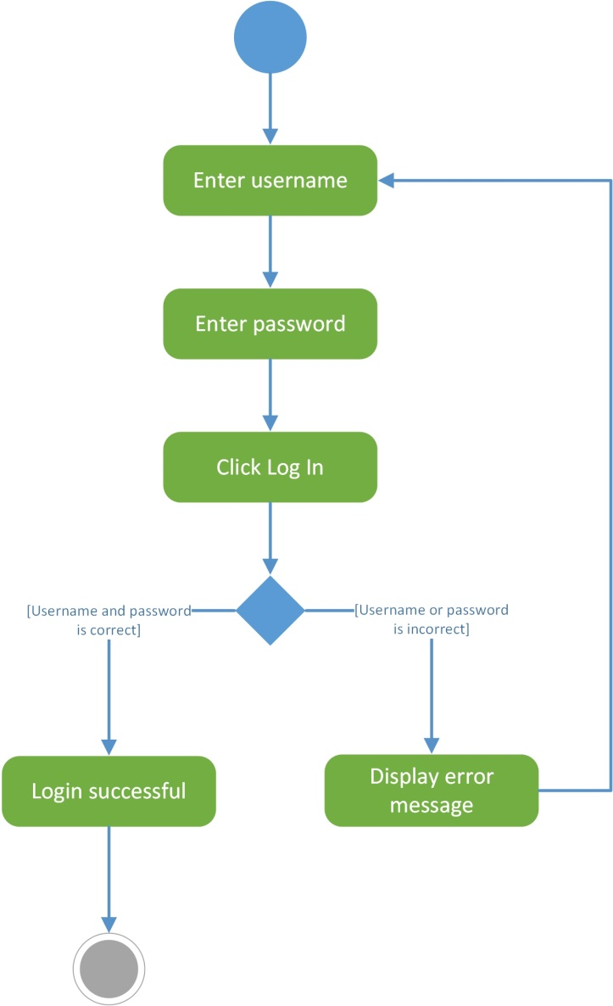

*Figure 4.1: Login Activity Diagram*

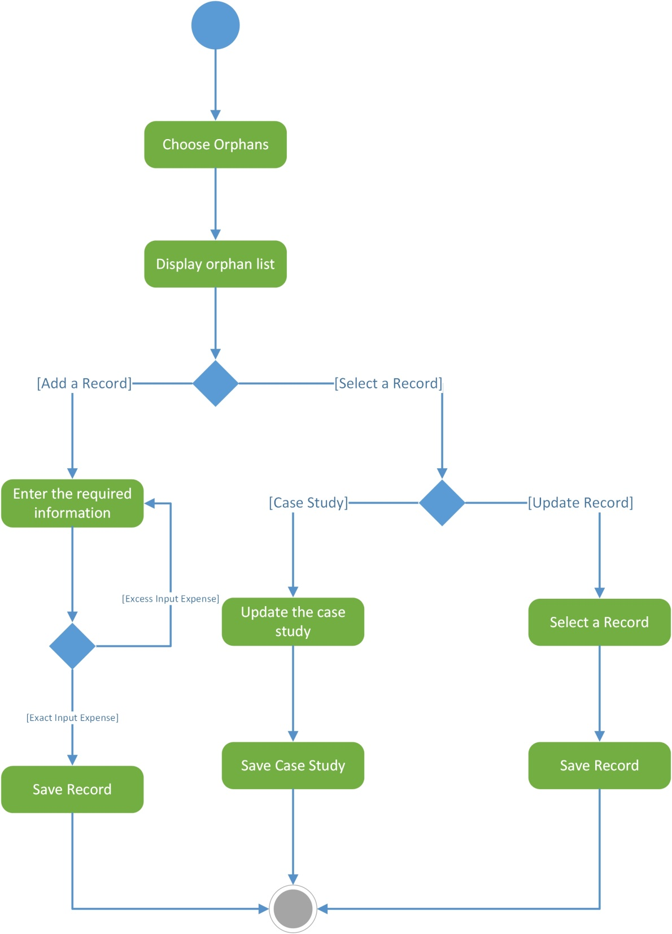

*Figure 4.2: Manage Orphan Records Activity Diagram*

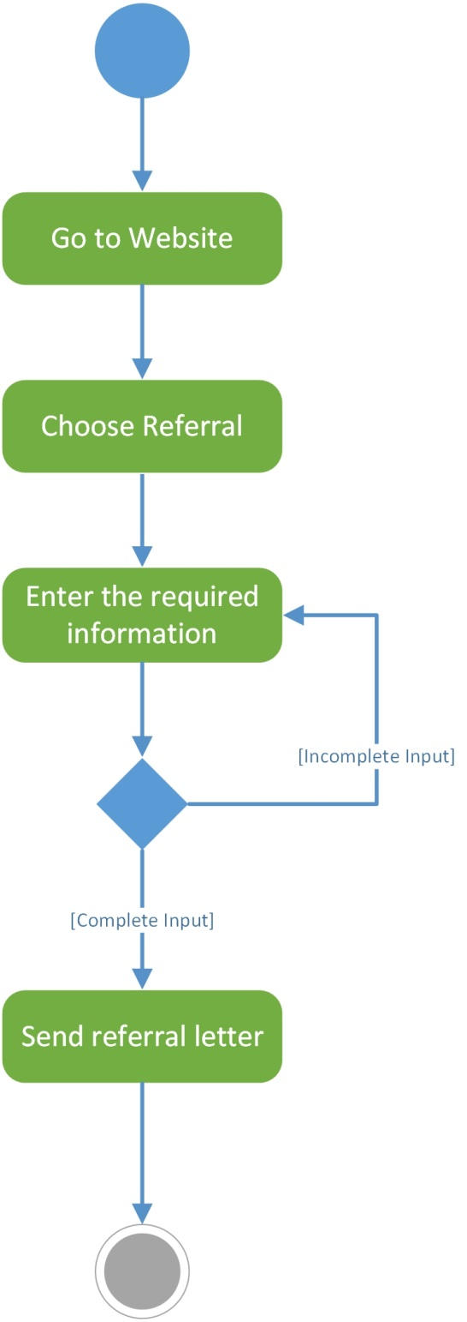

*Figure 4.3: Refer Orphans Activity Diagram*

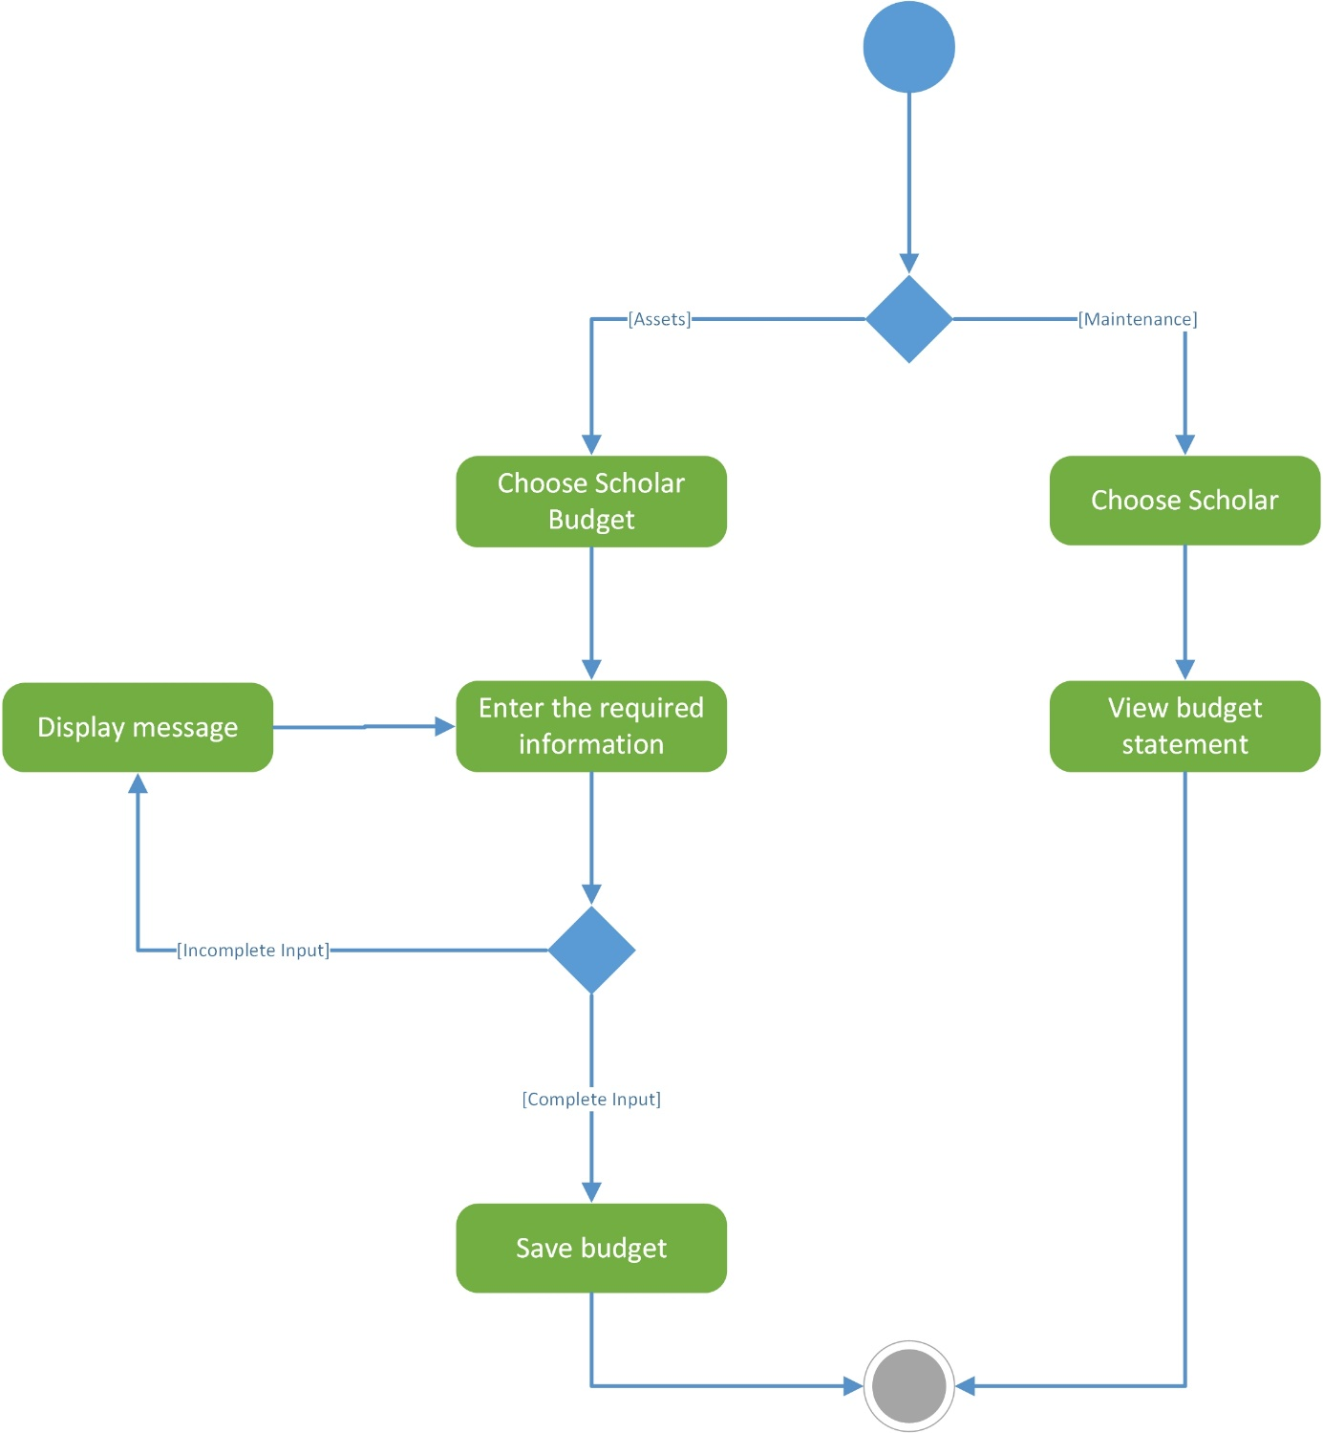

*Figure 4.4: Manage Orphan Assets Activity Diagram*

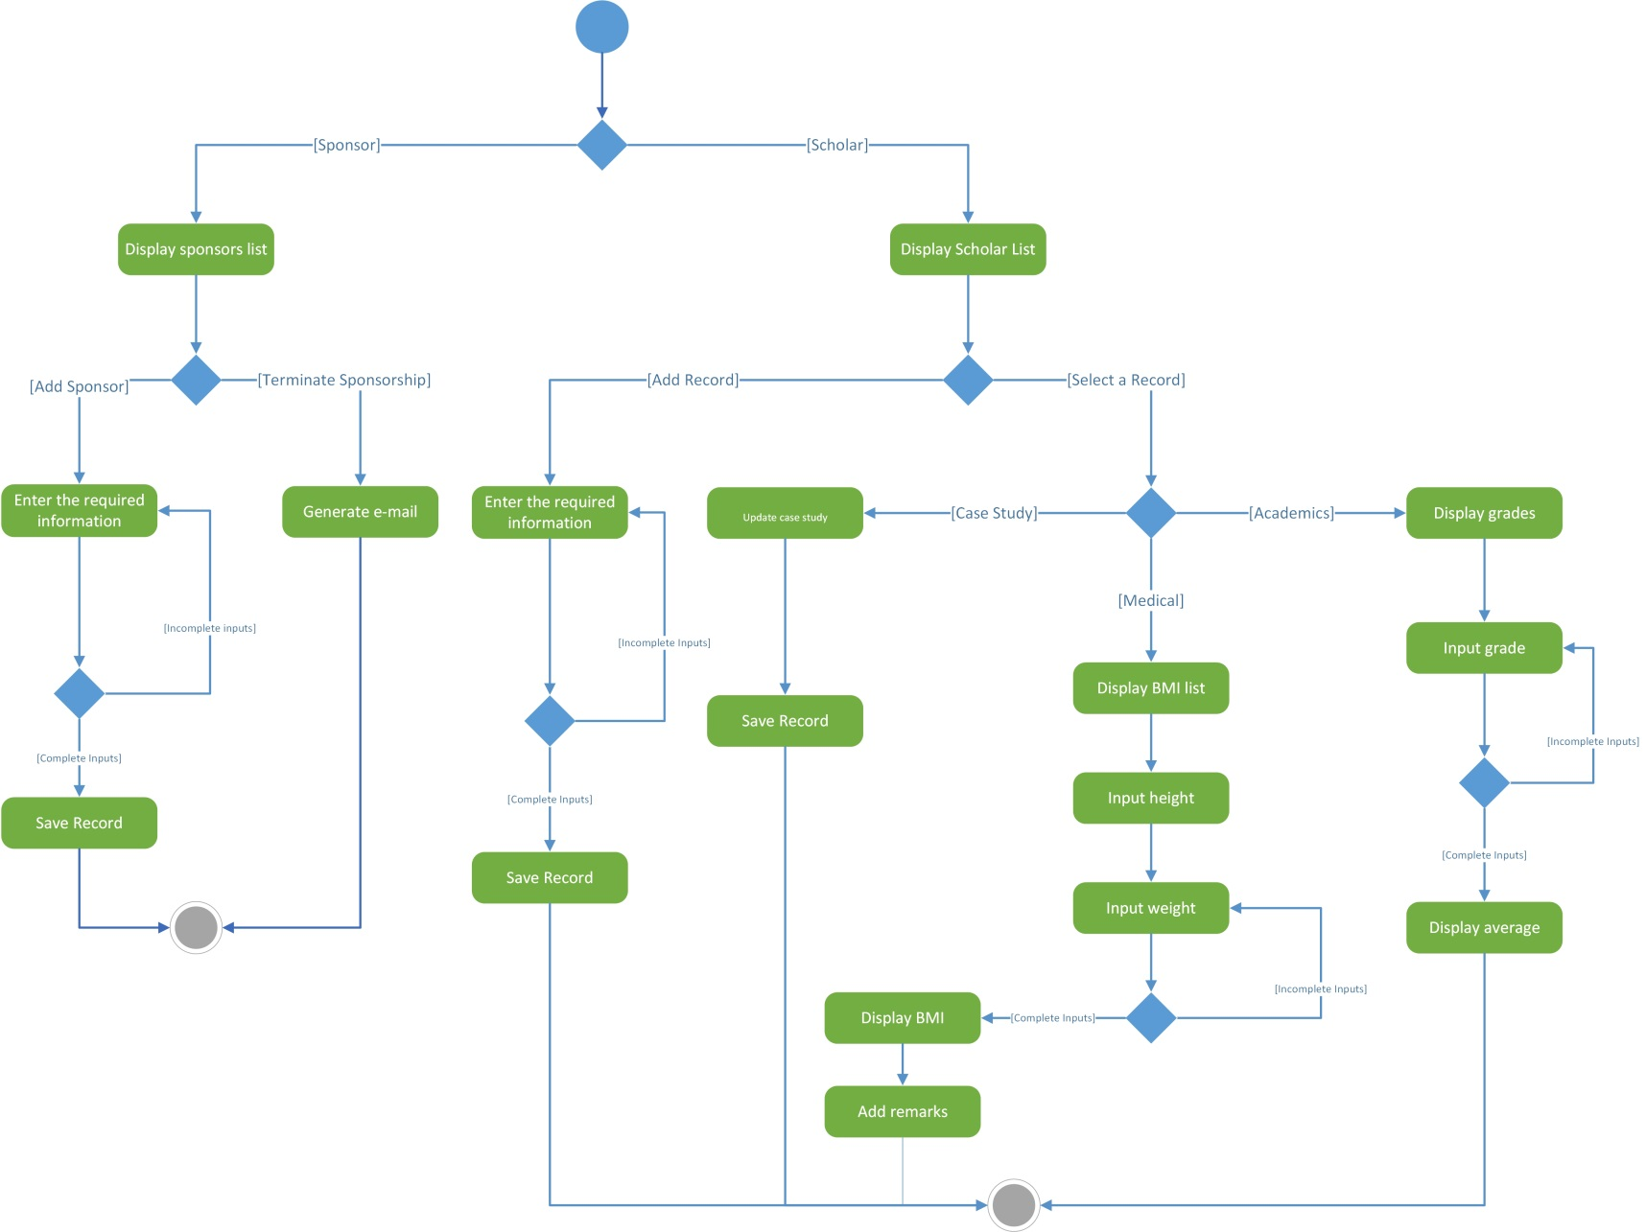

*Figure 4.5: Manage Scholar Records Activity Diagram*

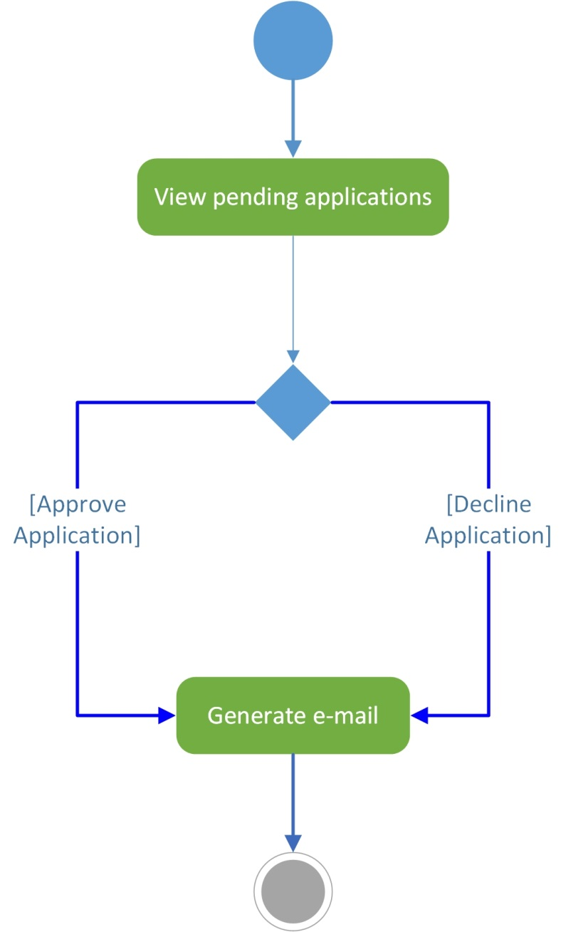

*Figure 4.6: Manage Client Applications Activity Diagram*

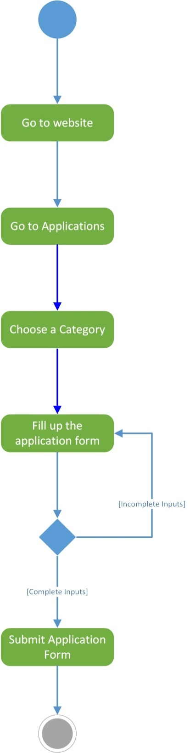

*Figure 4.7: Submit Application Forms Activity Diagram*

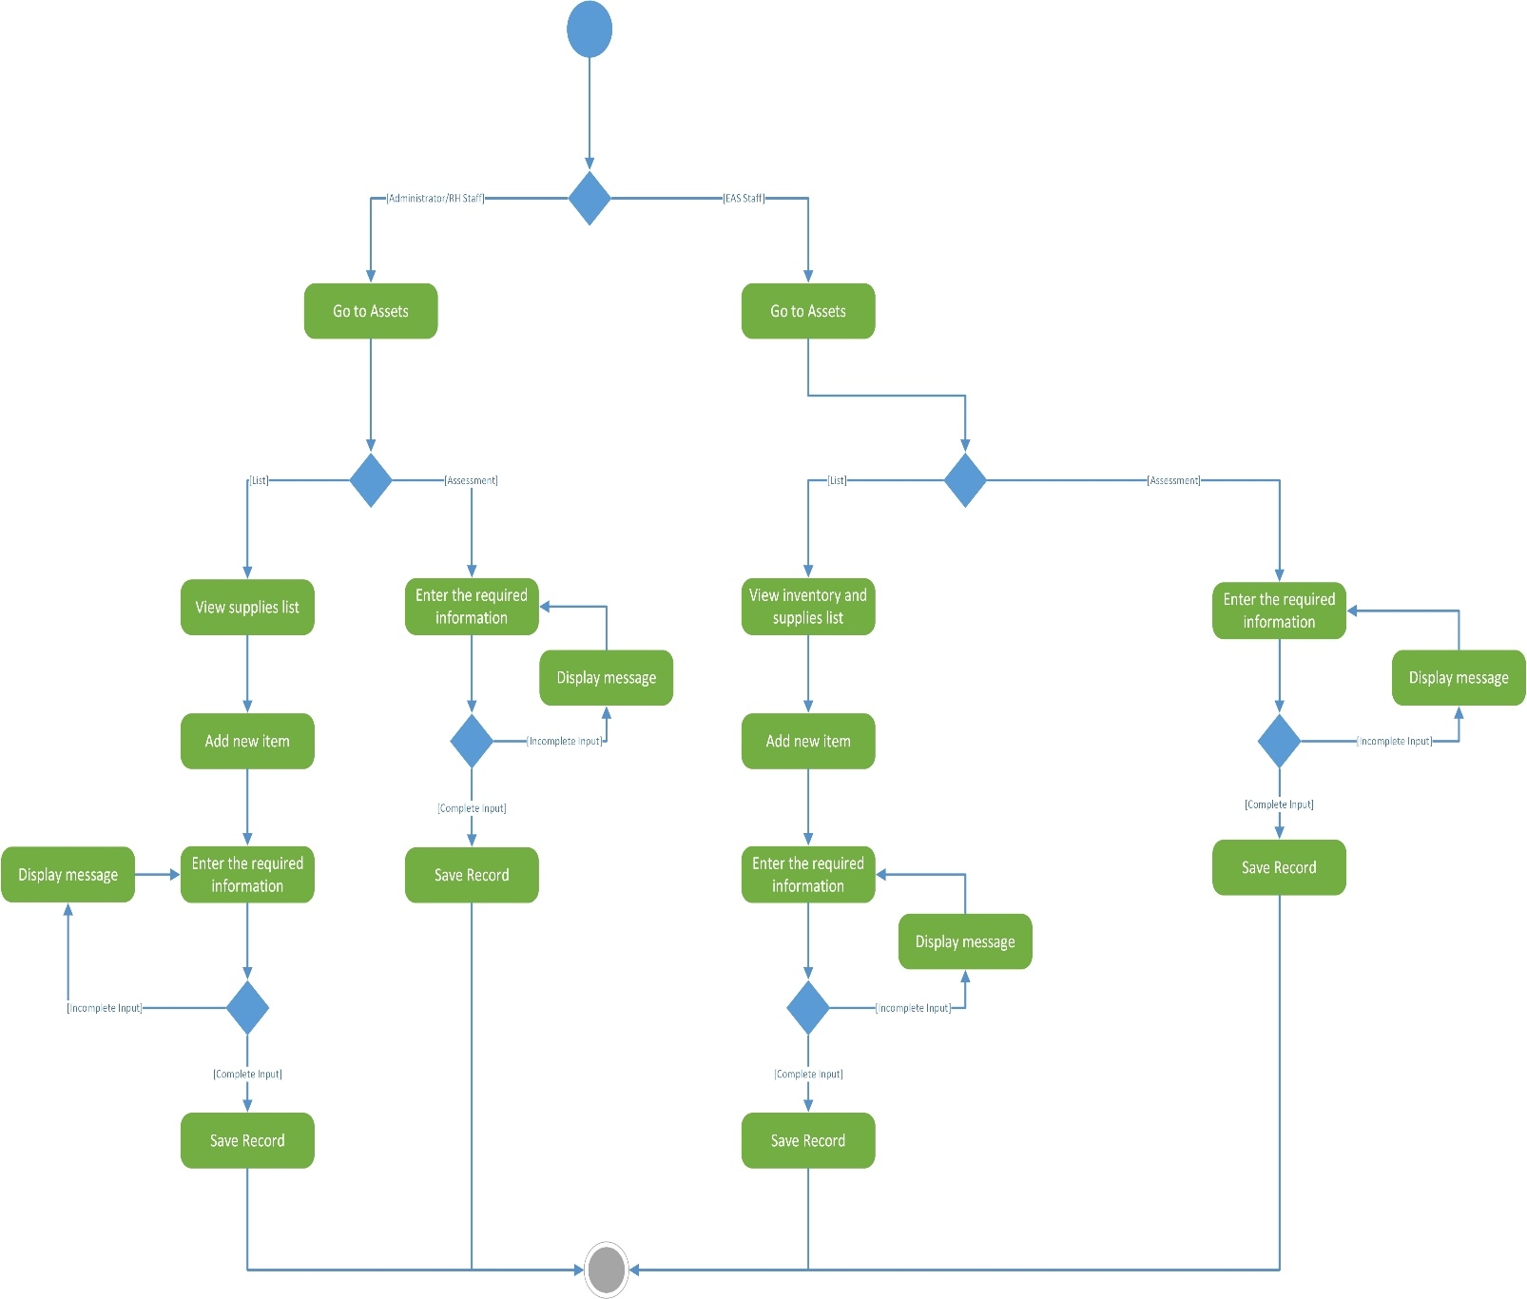

*Figure 4.8: Monitor Scholar Budget Activity Diagram*

*Figure 4.8: Manage Scholar Budget Activity Diagram*

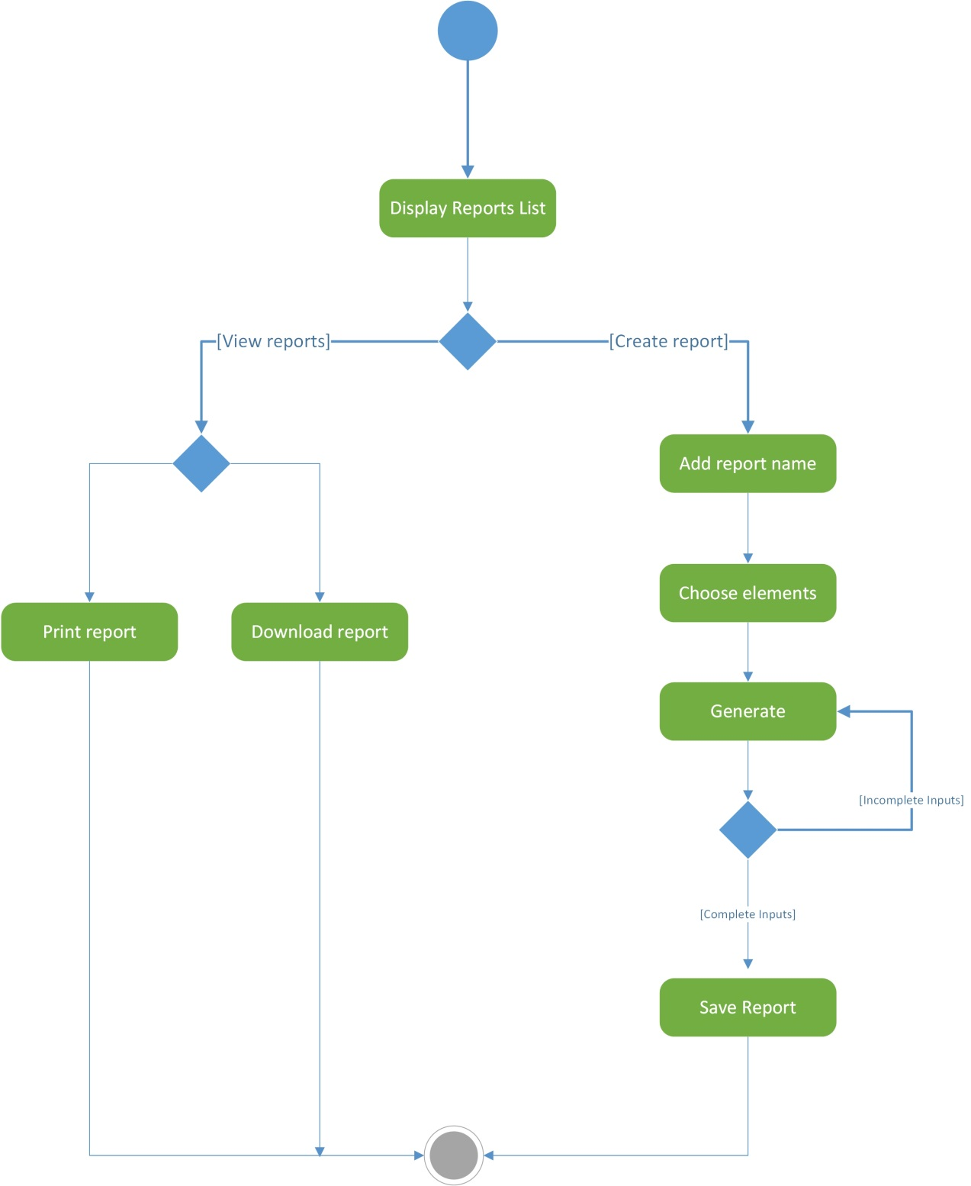

*Figure 4.9: View Application Status Activity Diagram*

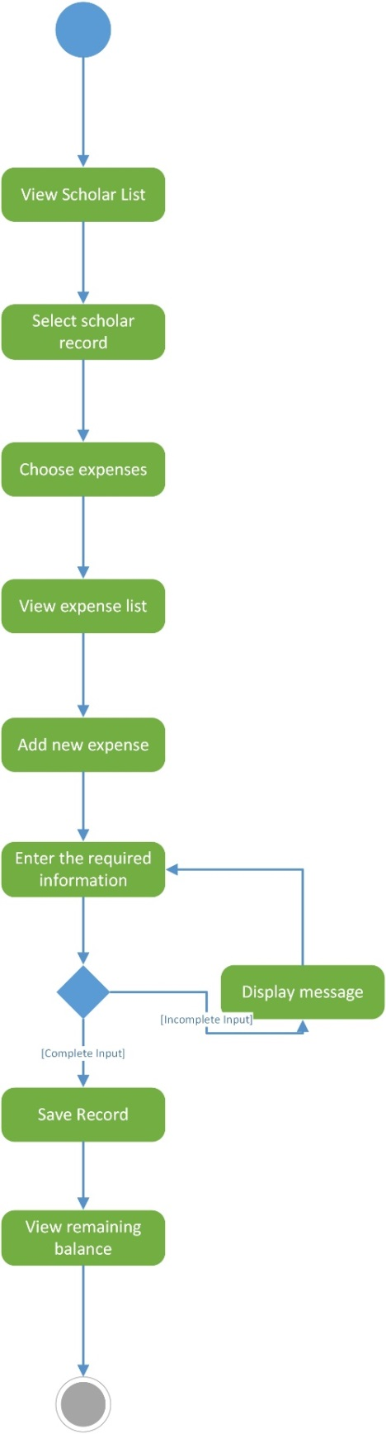

*Figure 4.10: Manage Scholar Expense Activity Diagram*

* + 1. GUI Design

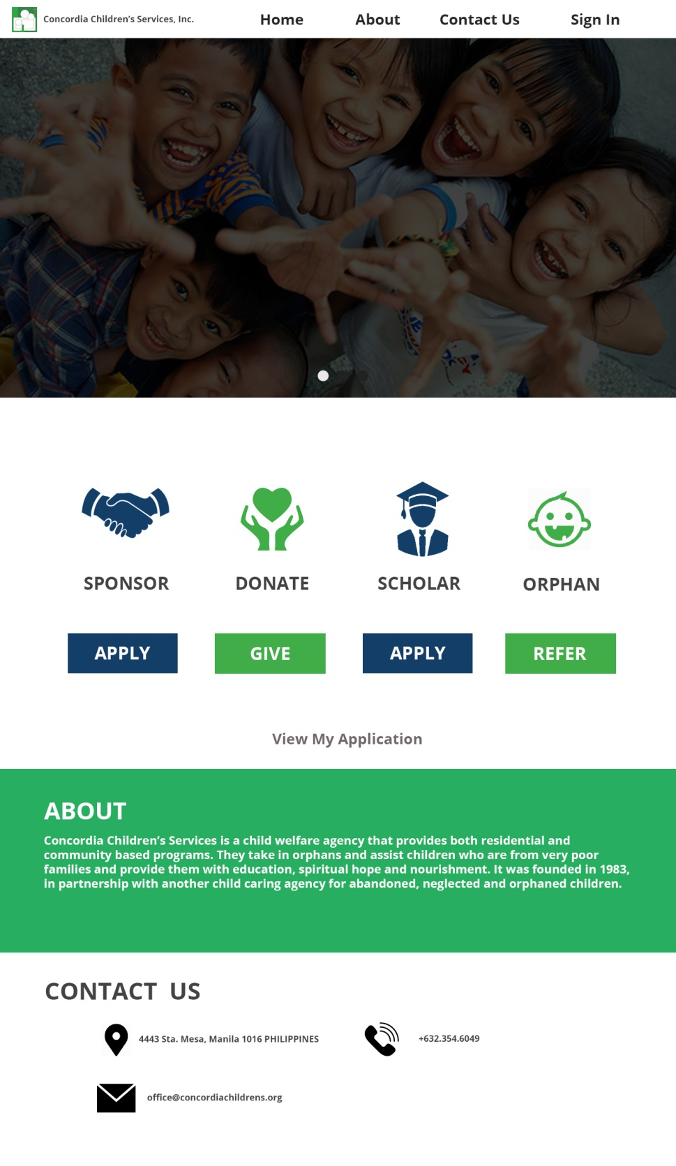

*Landing Page*

*Sponsorship Application (Sponsor)*

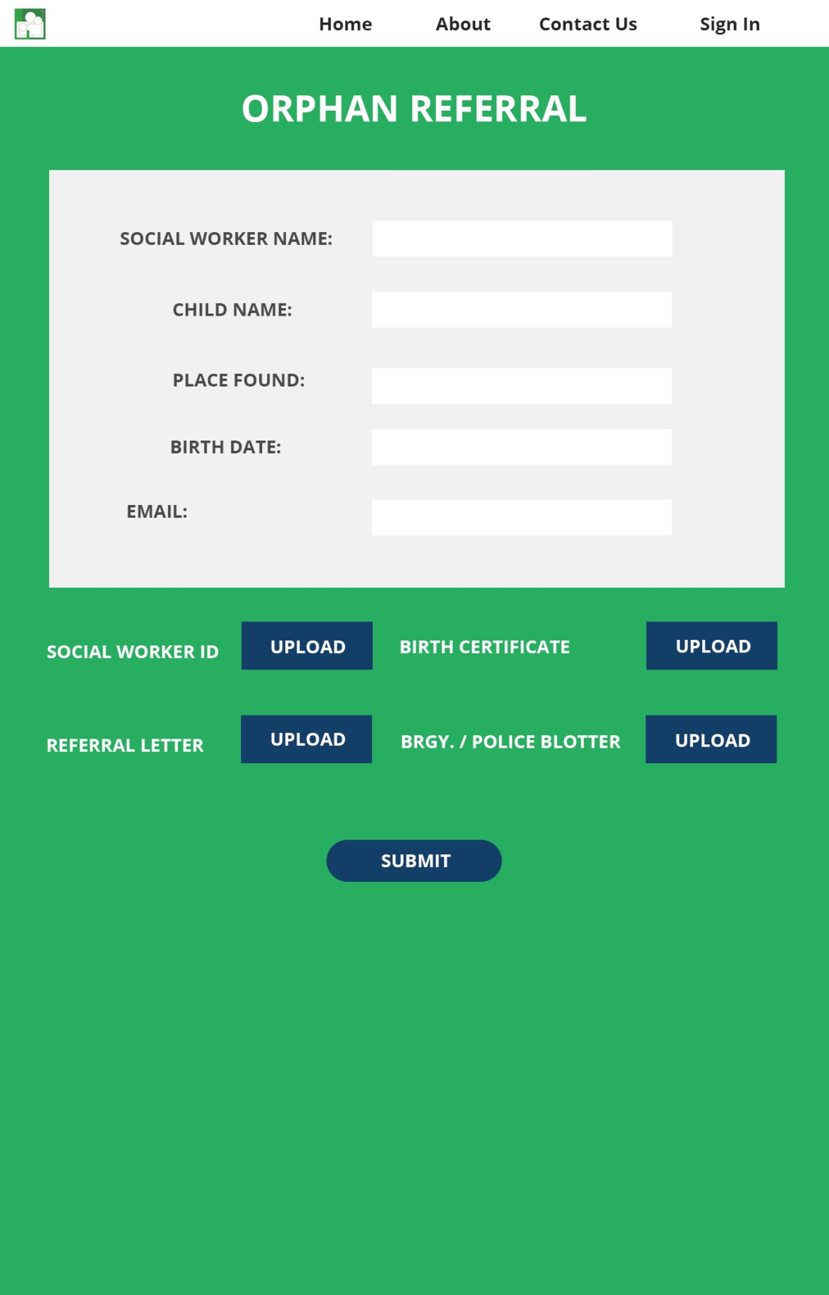

*Orphan Referral (Social Worker)*



*Code Input (Sponsor, Scholar, Social Worker)*

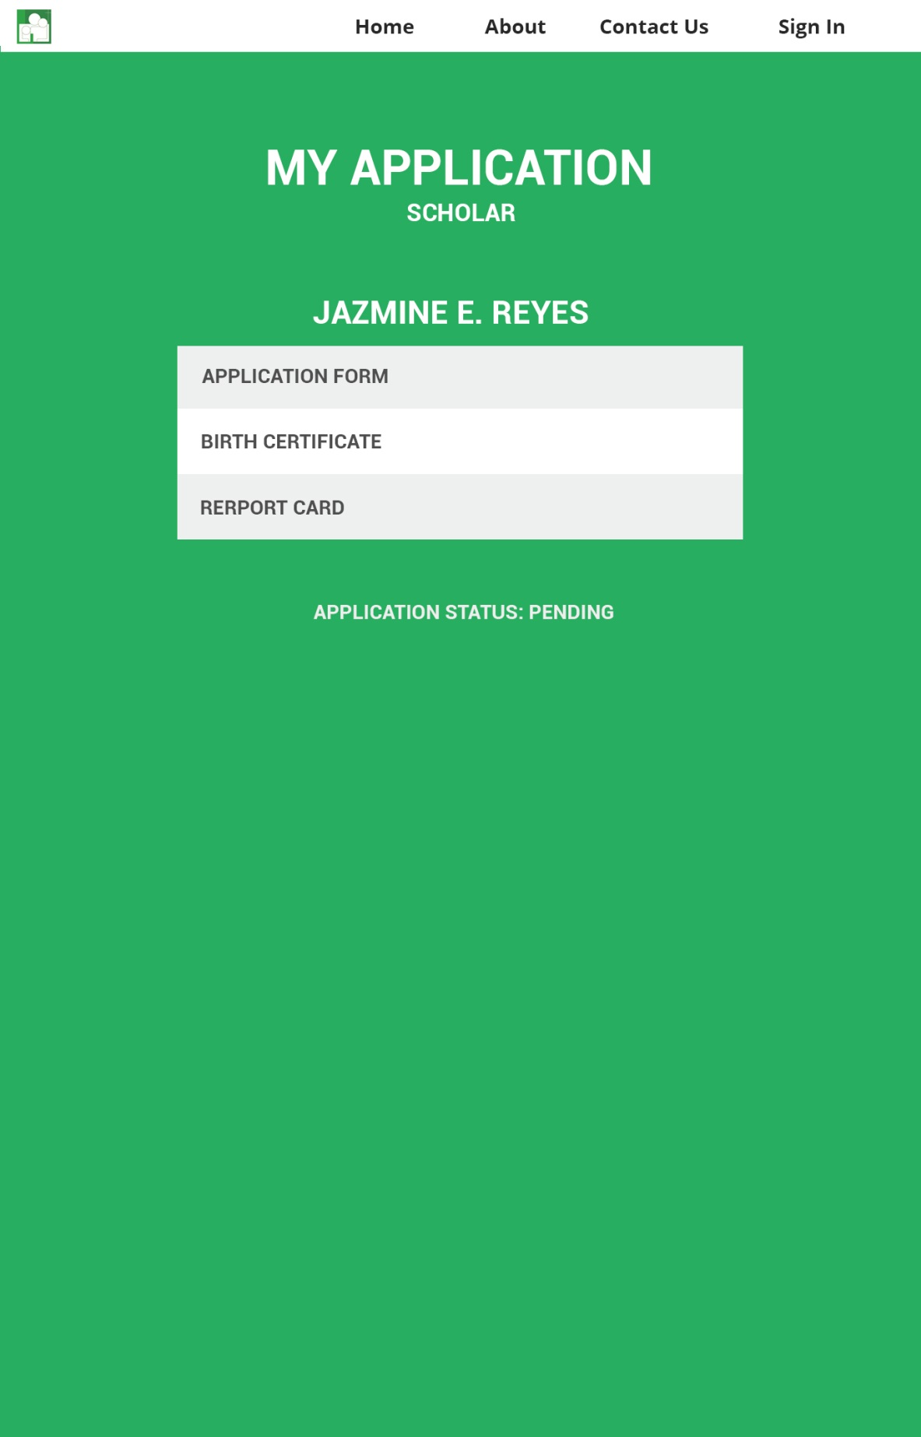

*View Application Status (Scholar)*

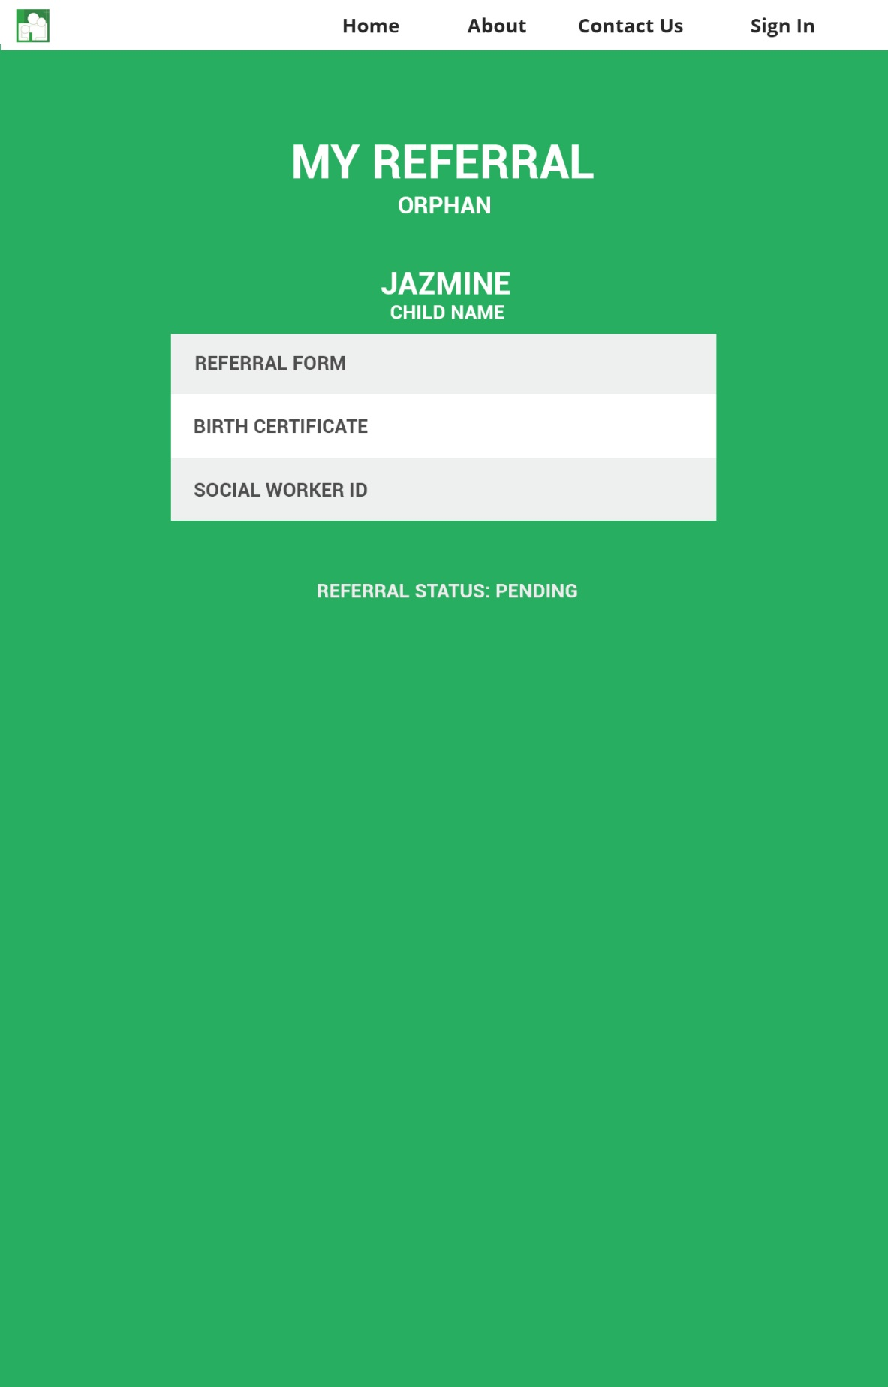

*View Referral Status (Social Worker)*

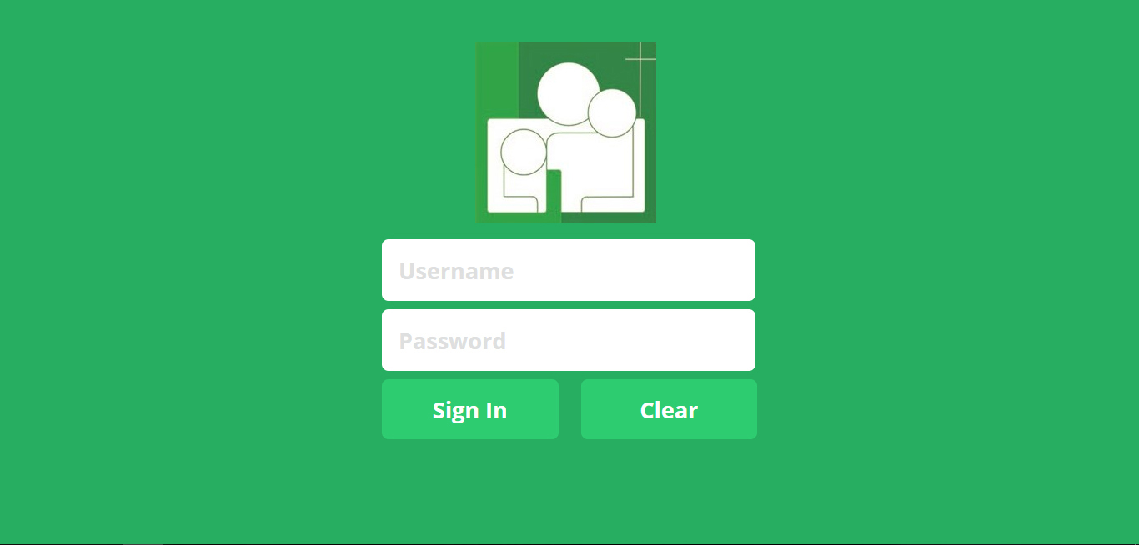

*Log In (Administrator, Staff, Sponsor)*

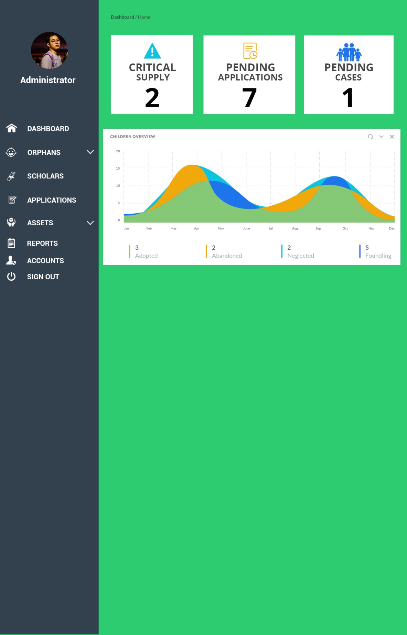

*Dashboard (Administrator)*

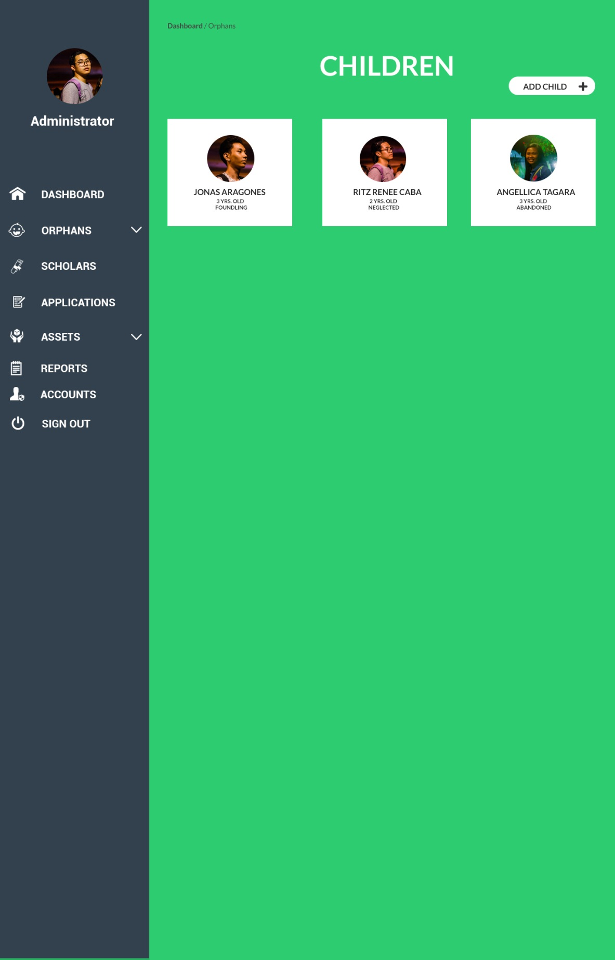

*Orphan Maintenance (Administrator)*

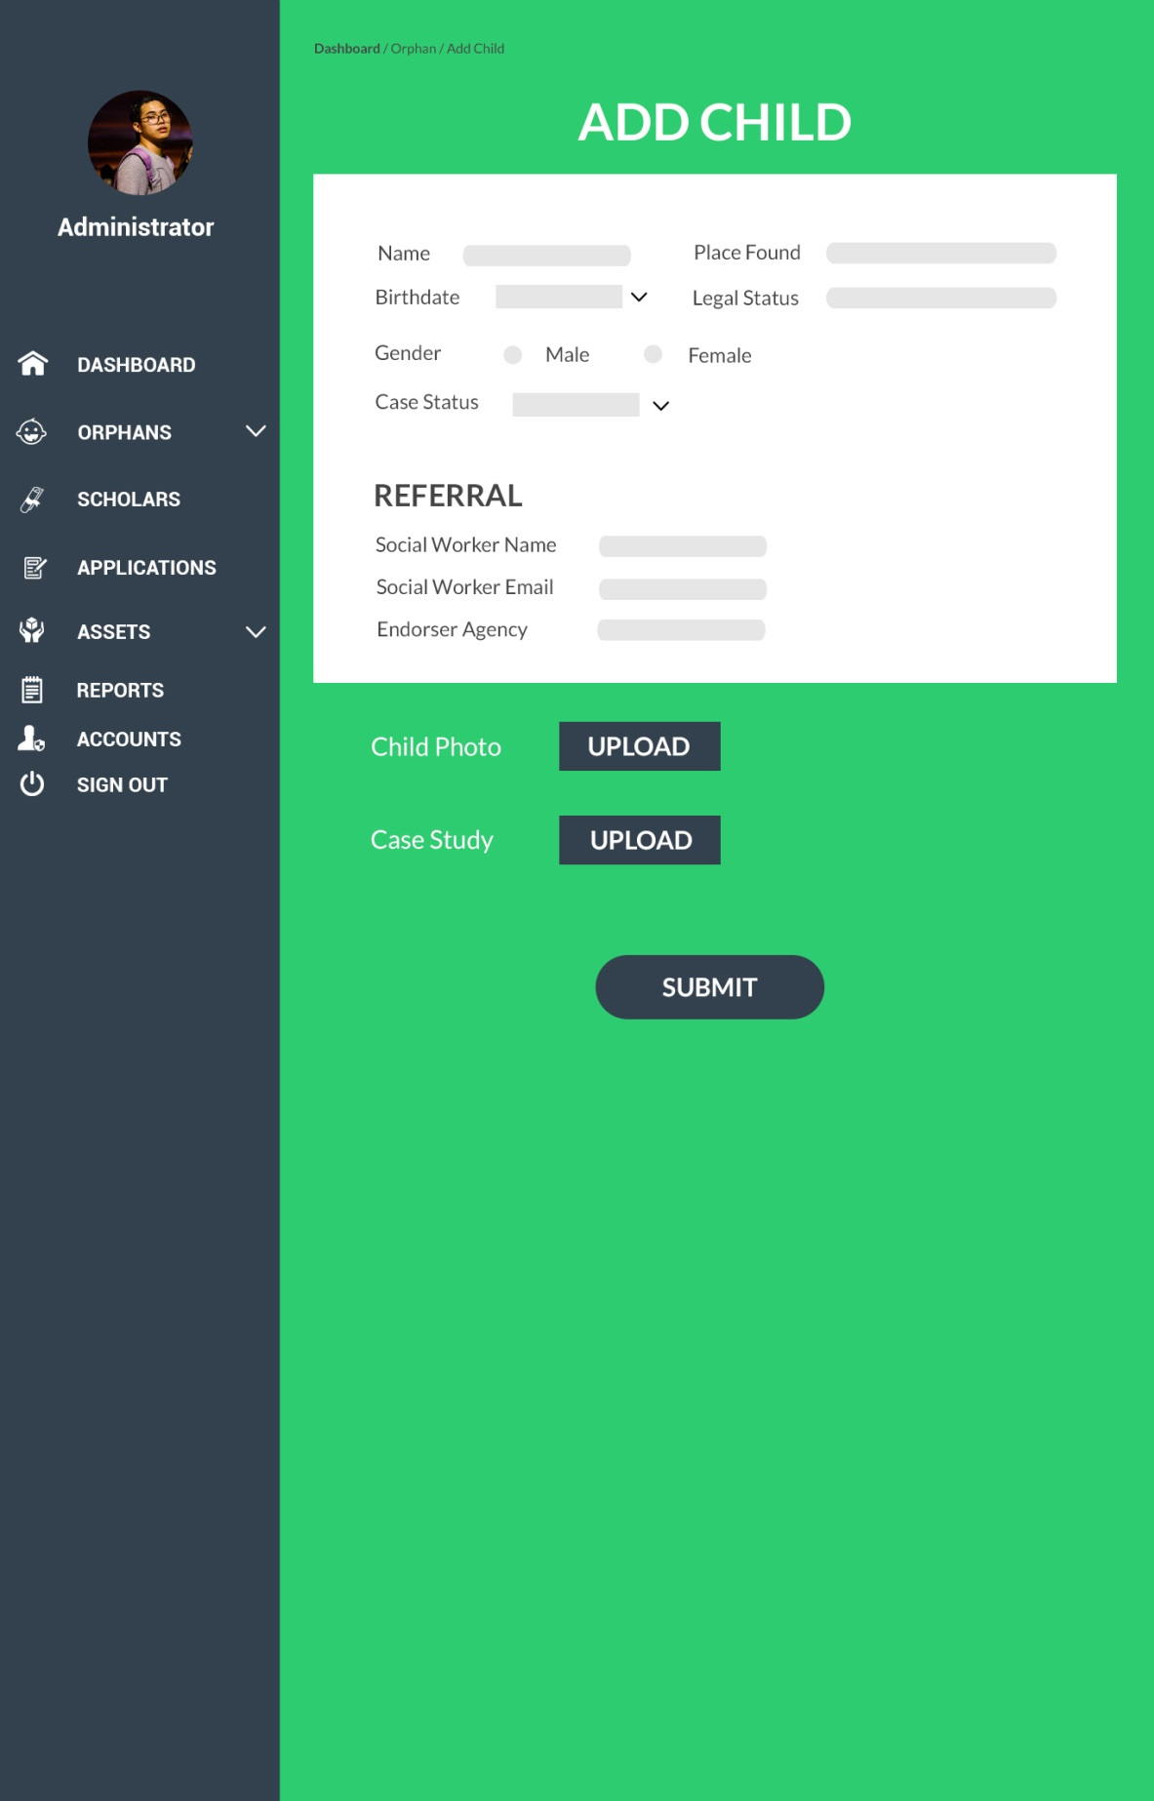

*Add Orphan (Administrator)*

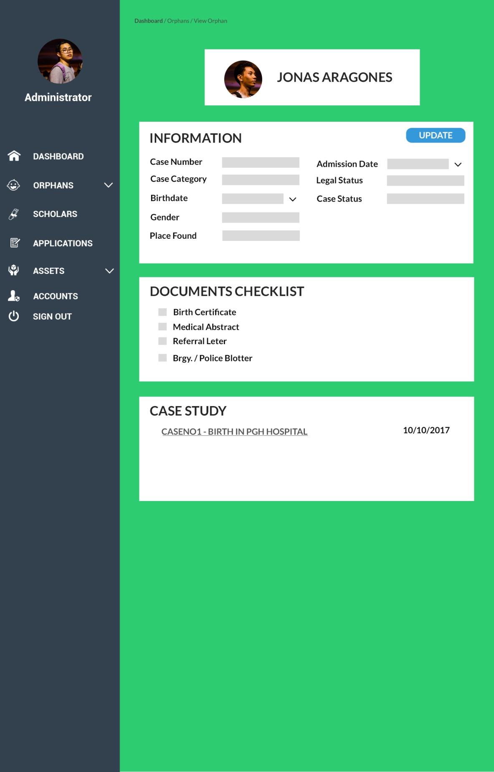

*View Orphan (Administrator)*

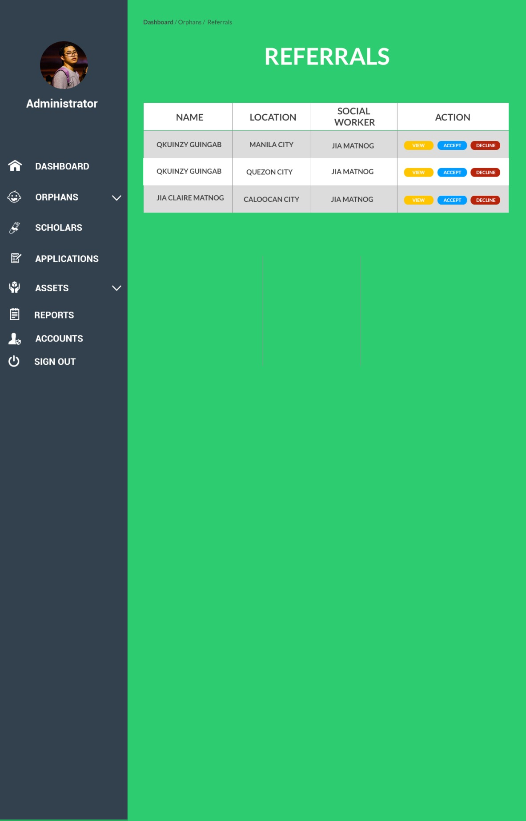

*Orphan Referrals (Administrator)*

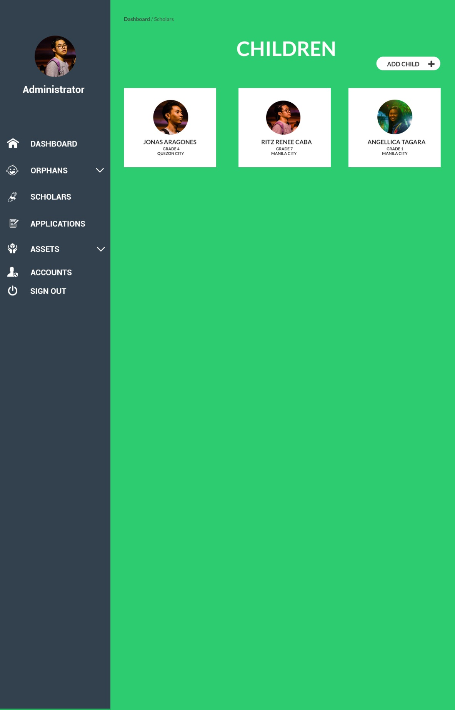

*Scholar Maintenance (Administrator)*

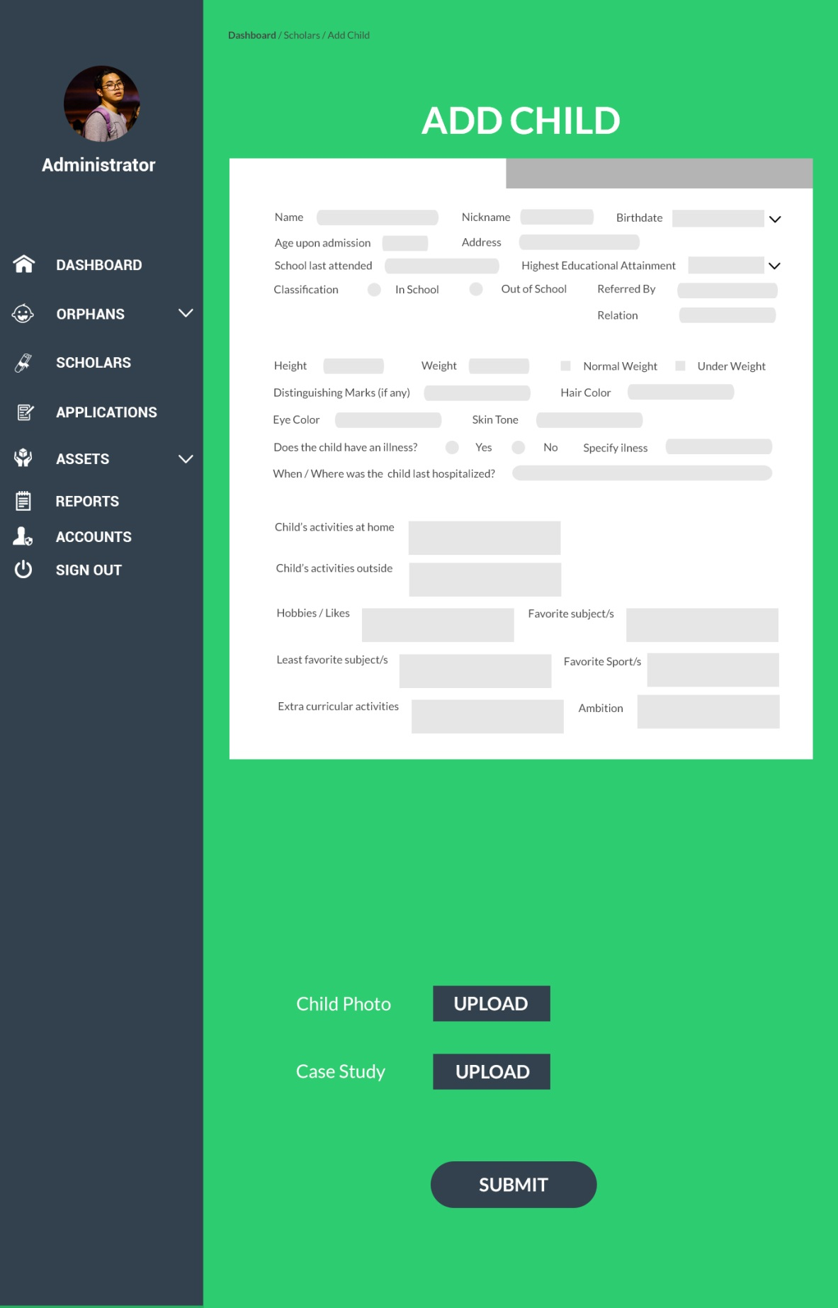

*Add Scholar (Administrator)*

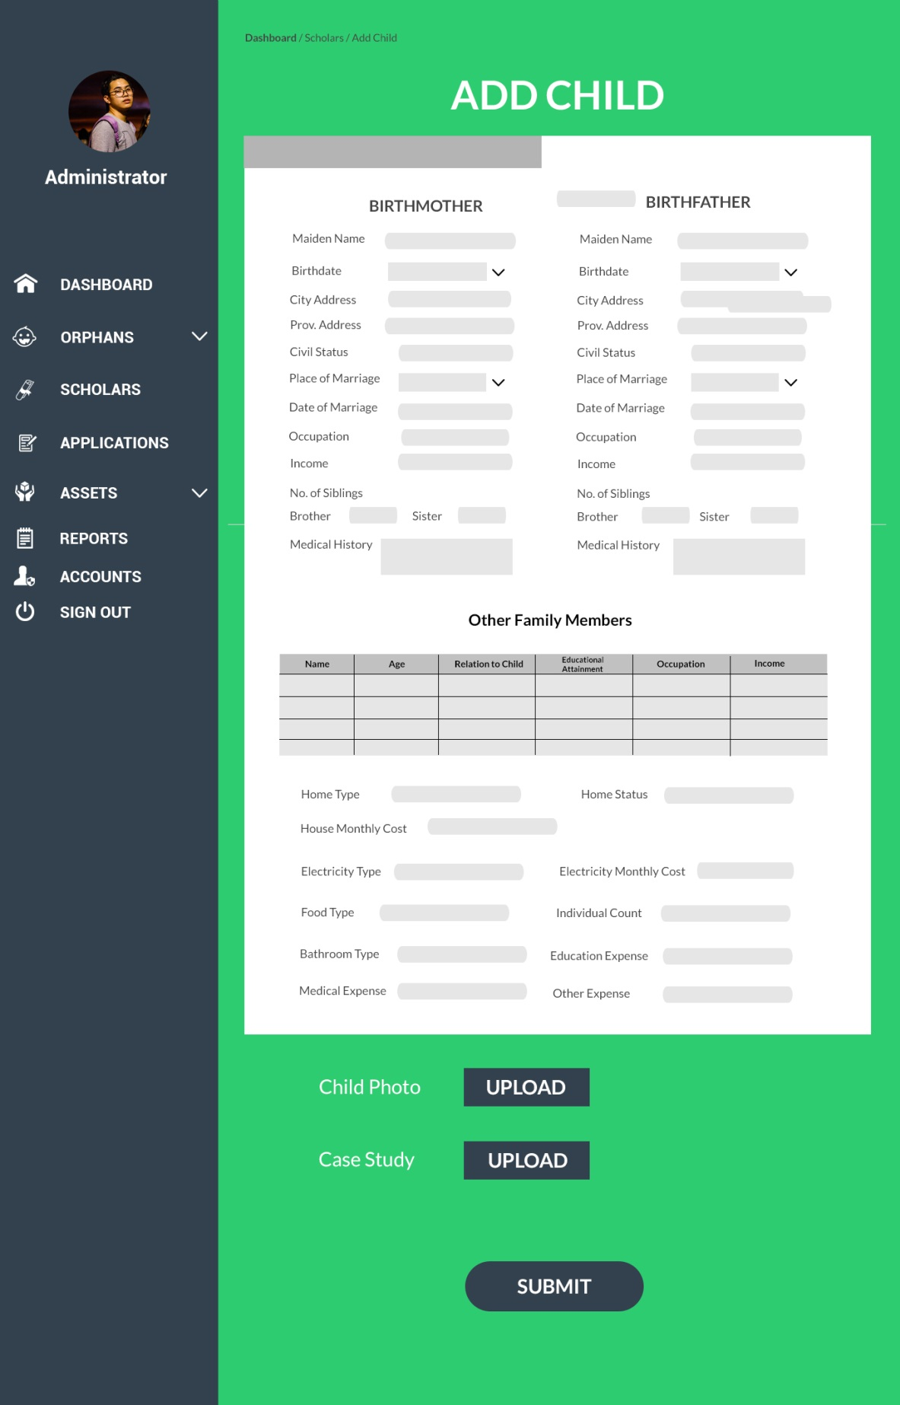

*Add Scholar (Administrator)*

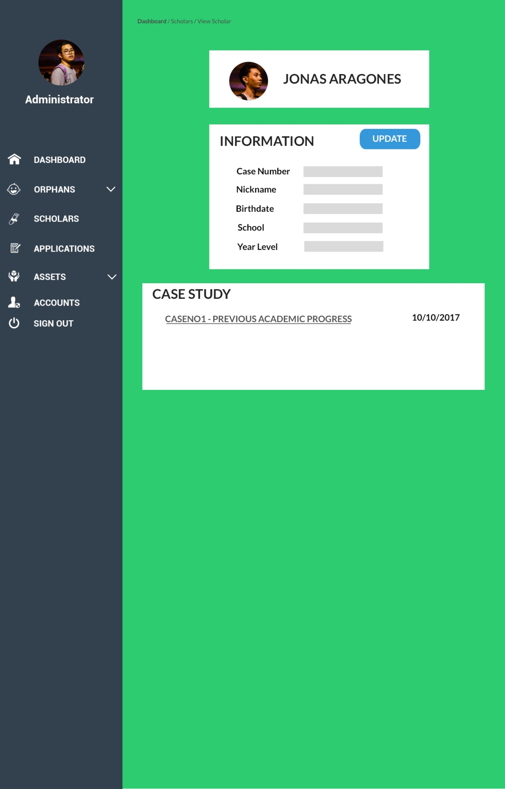

*View Scholar (Administrator)*

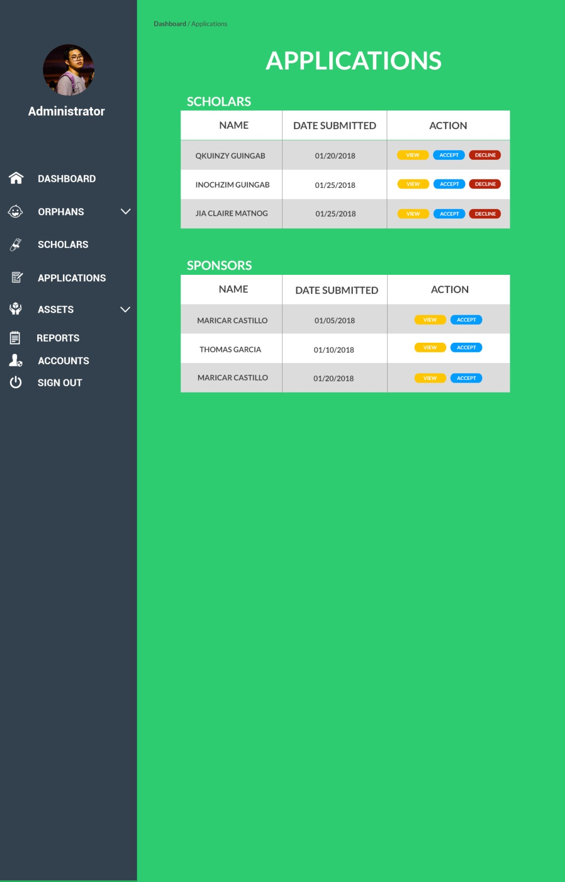

*Application Monitoring (Administrator)*

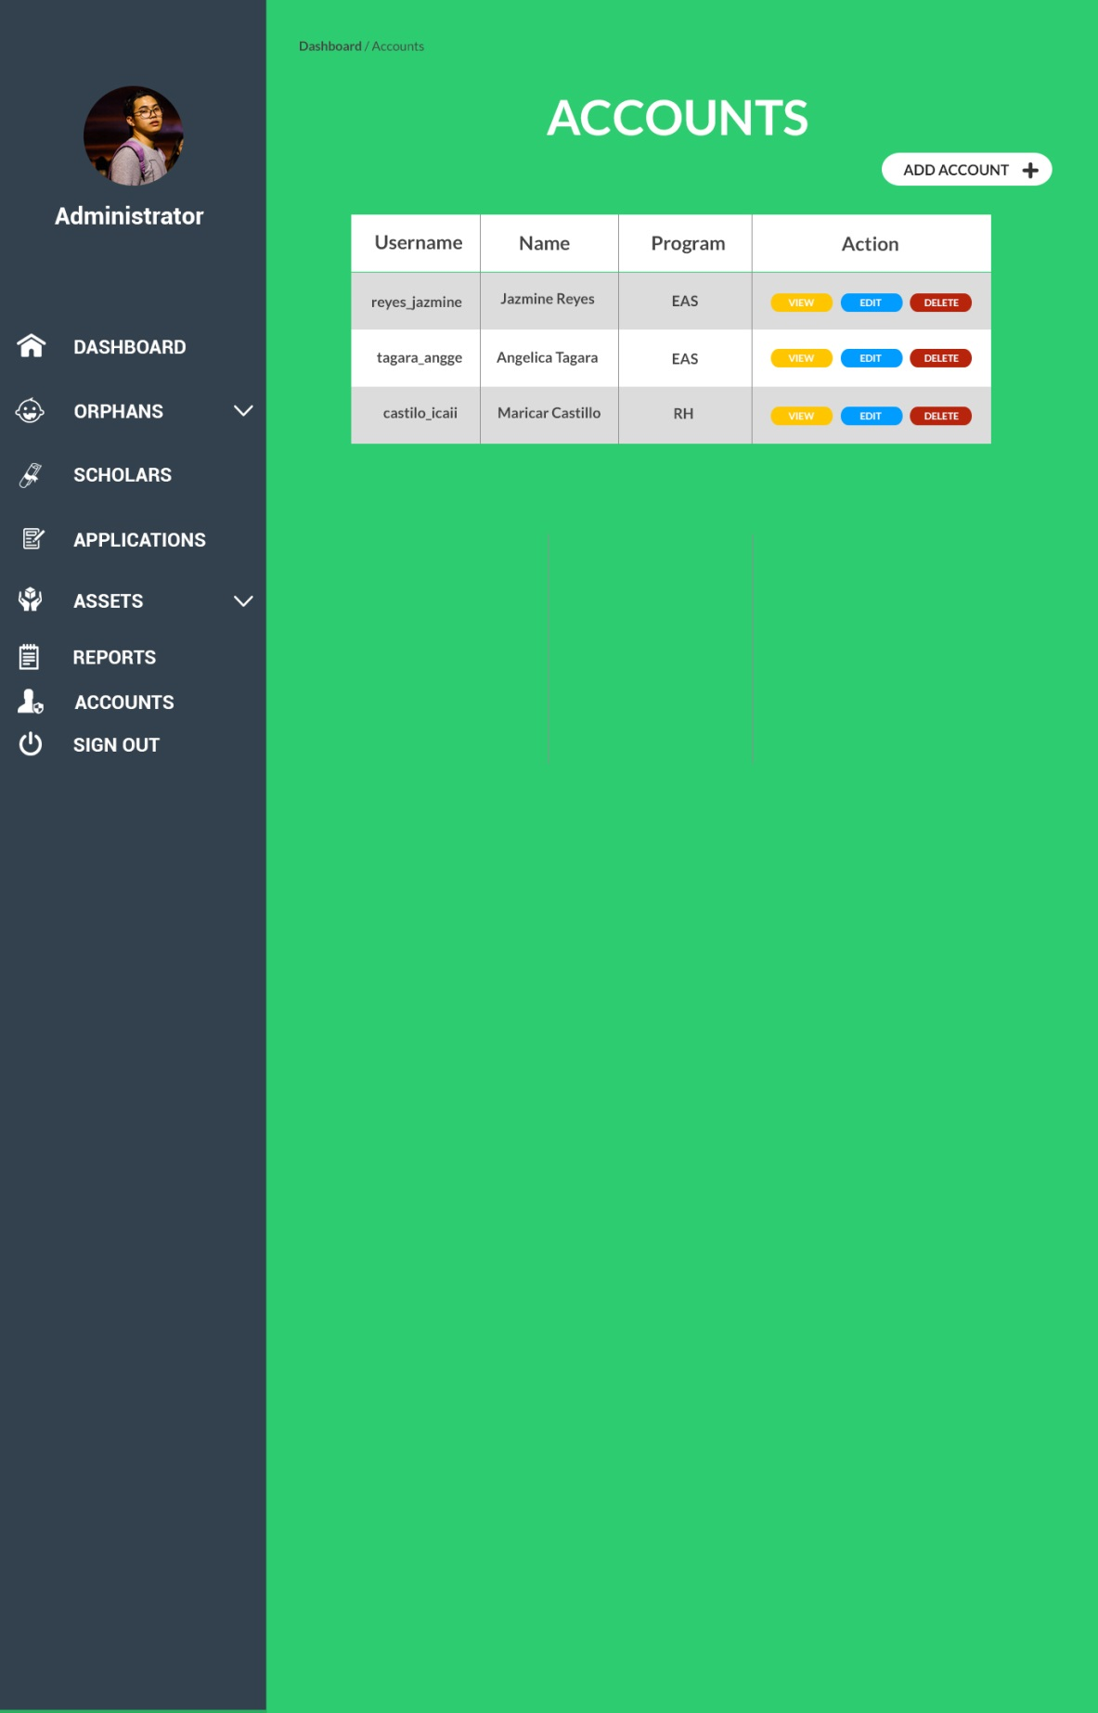

*Accounts (Administrator)*

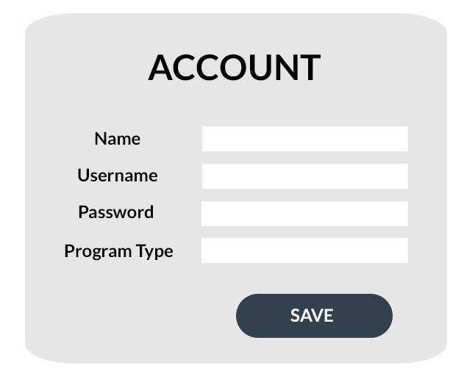

*Add Account Modal (Administrator)*

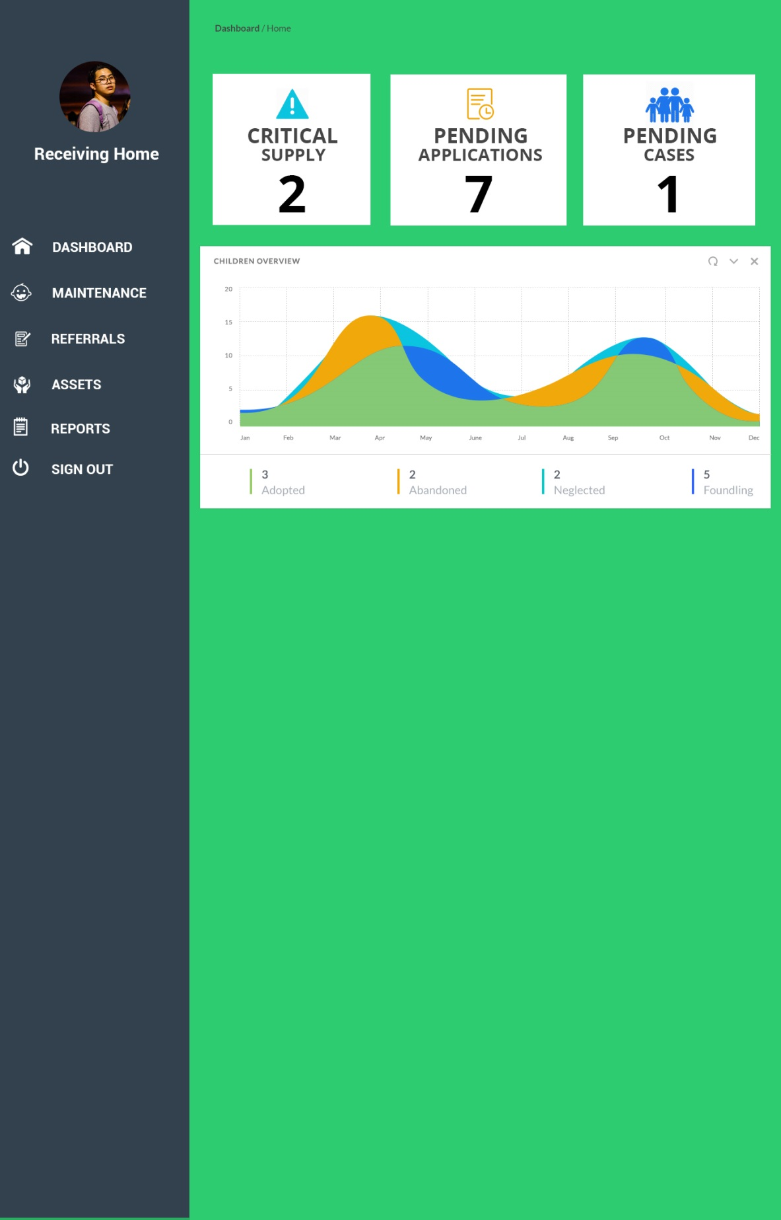

*Dashboard (RH Staff)*

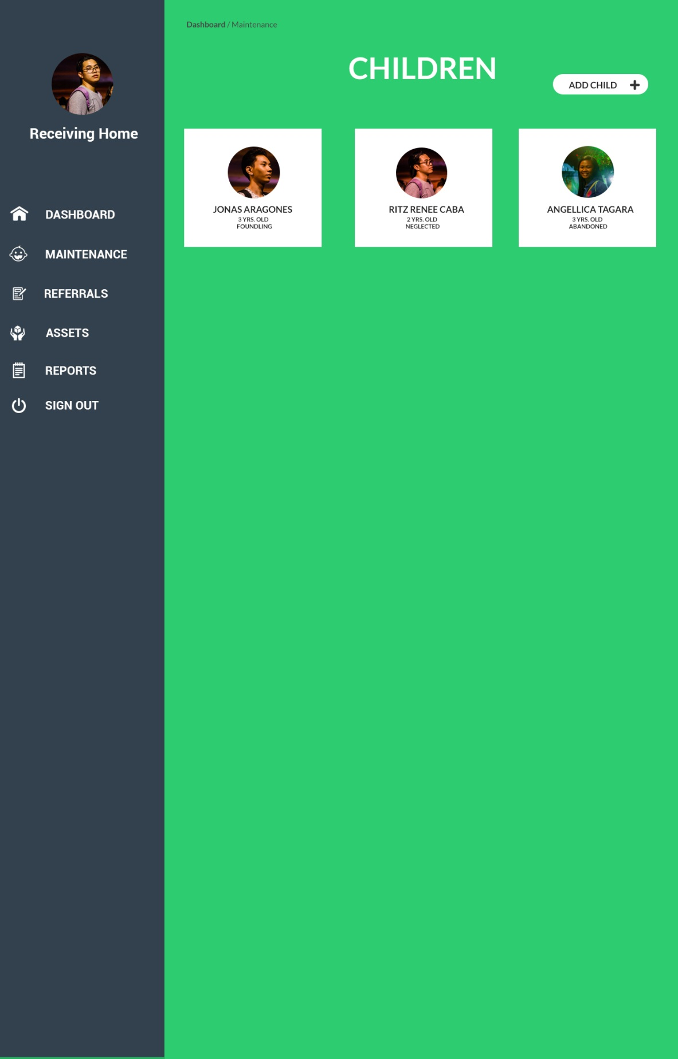

*Orphan Maintenance (Administrator)*

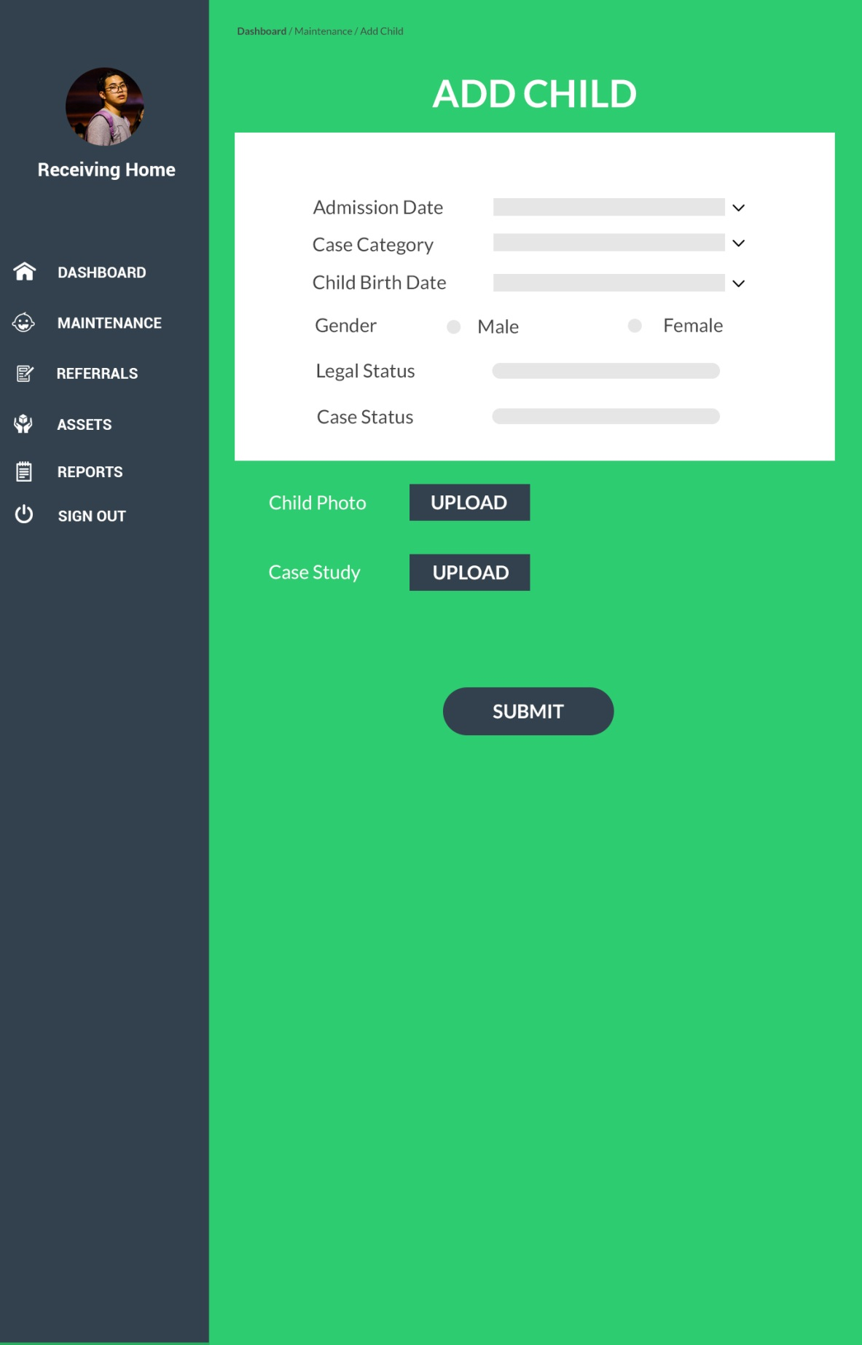

*Add Orphan (RH Staff)*

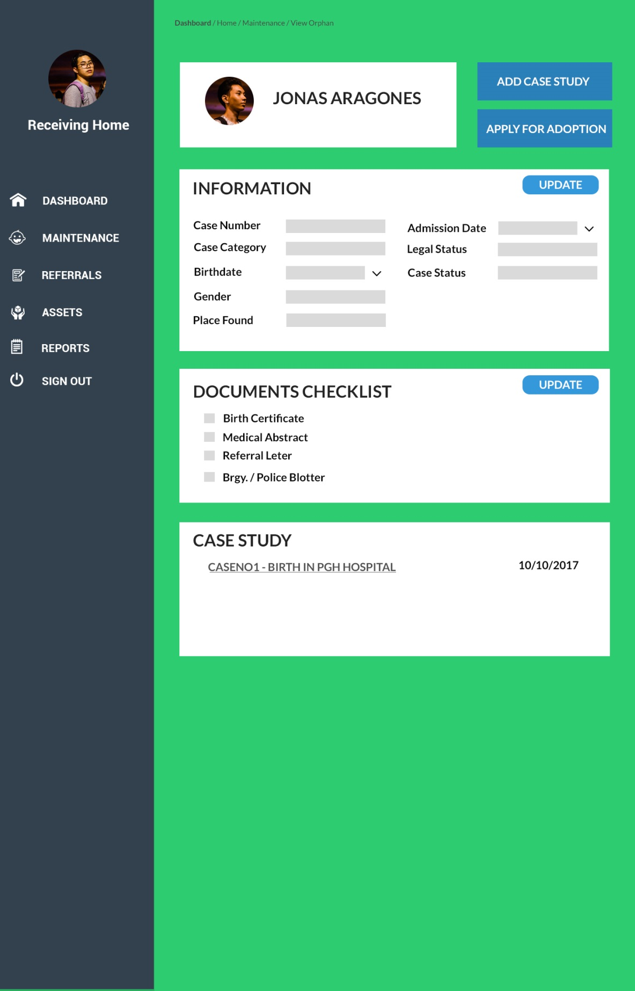

*View Orphan (RH Staff)*

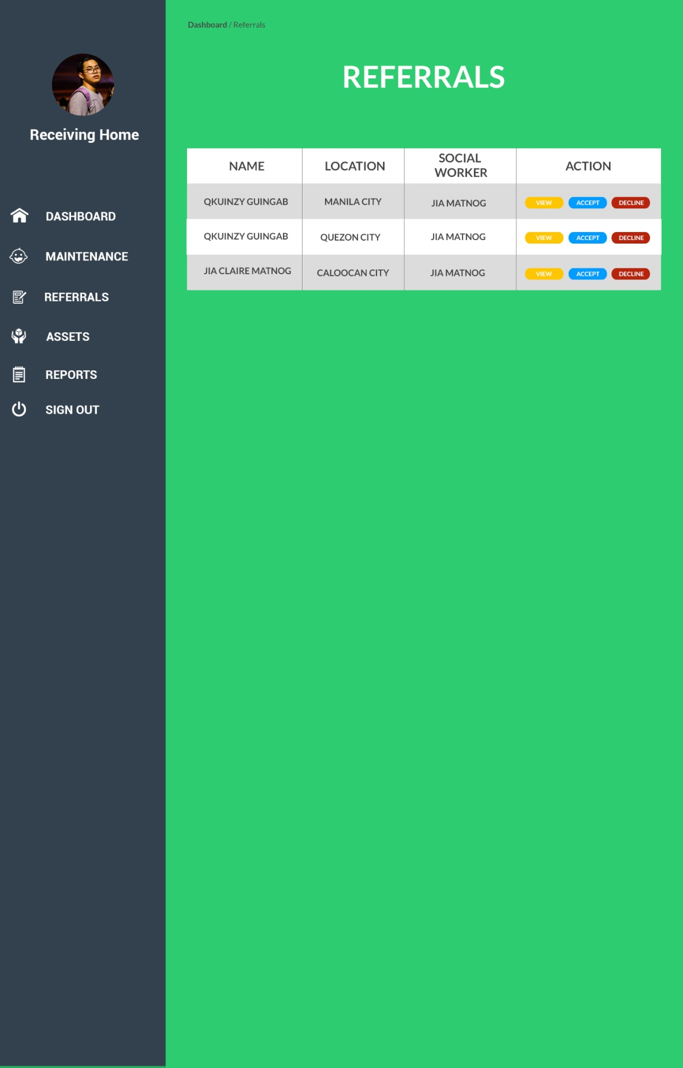

*Referrals (RH Staff)*

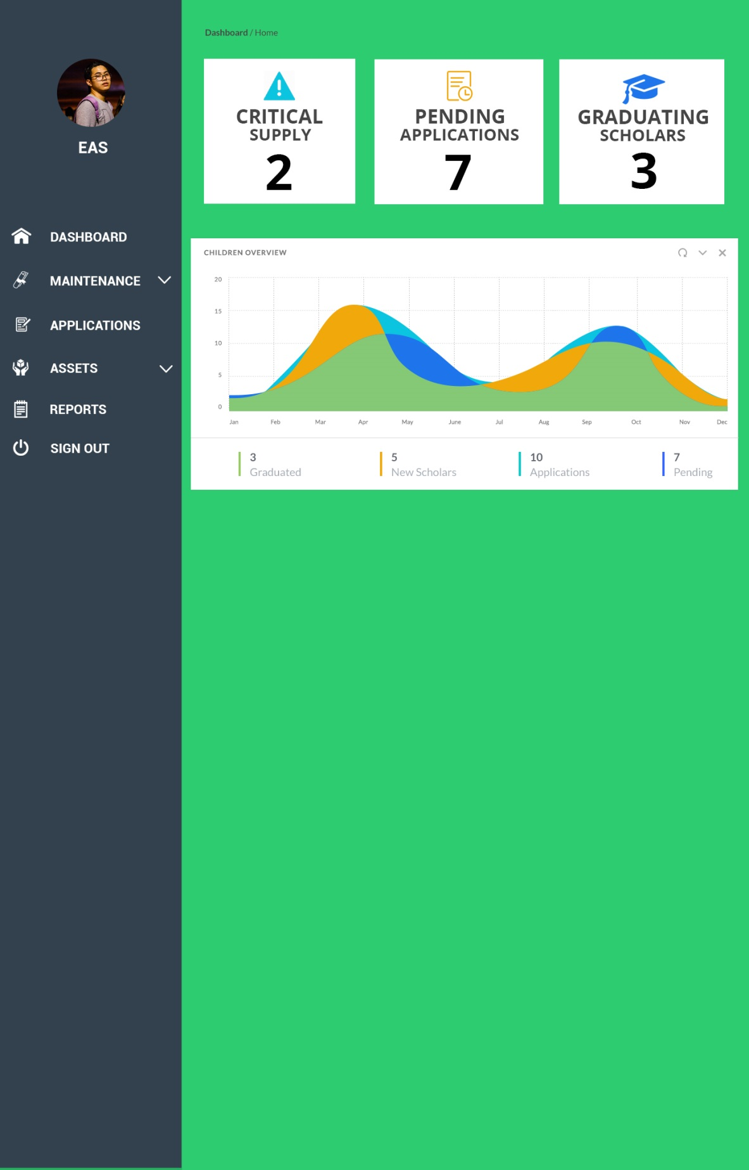

*Dashboard (EAS Staff)*

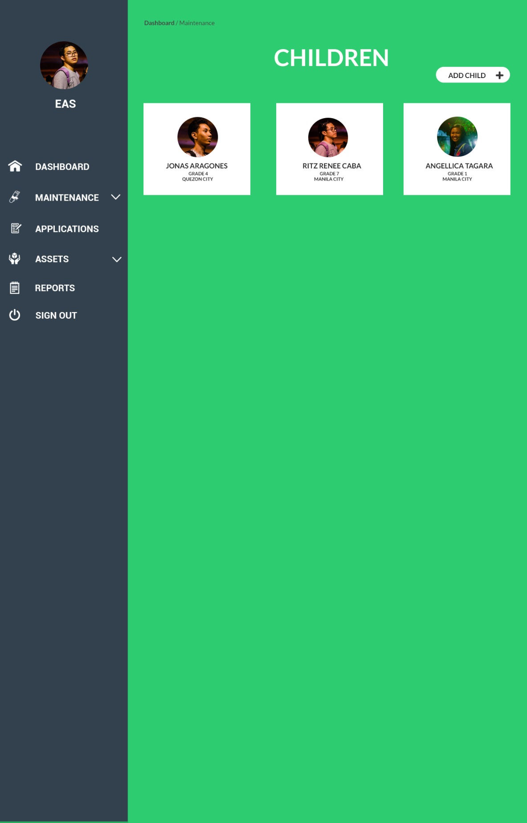

*Scholar Maintenance (EAS Staff)*

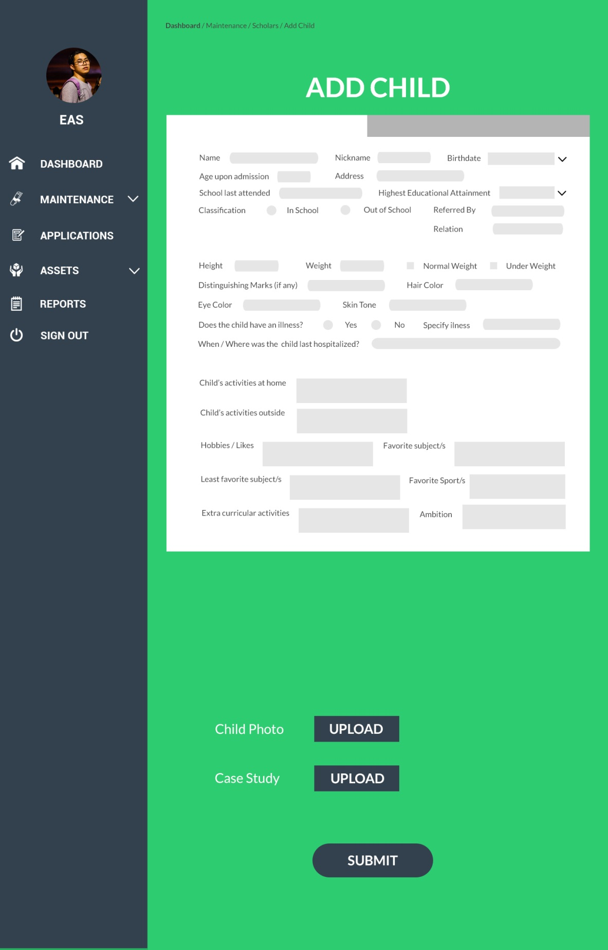

*Add Scholar (EAS Staff)*

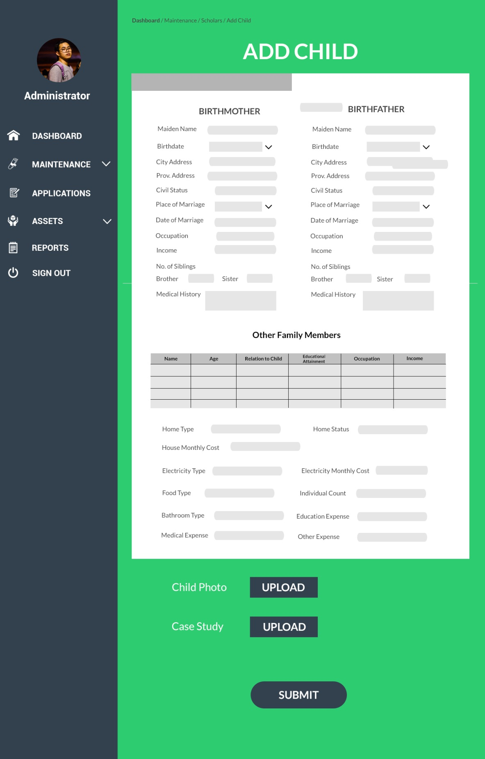

*Add Scholar (EAS Staff)*

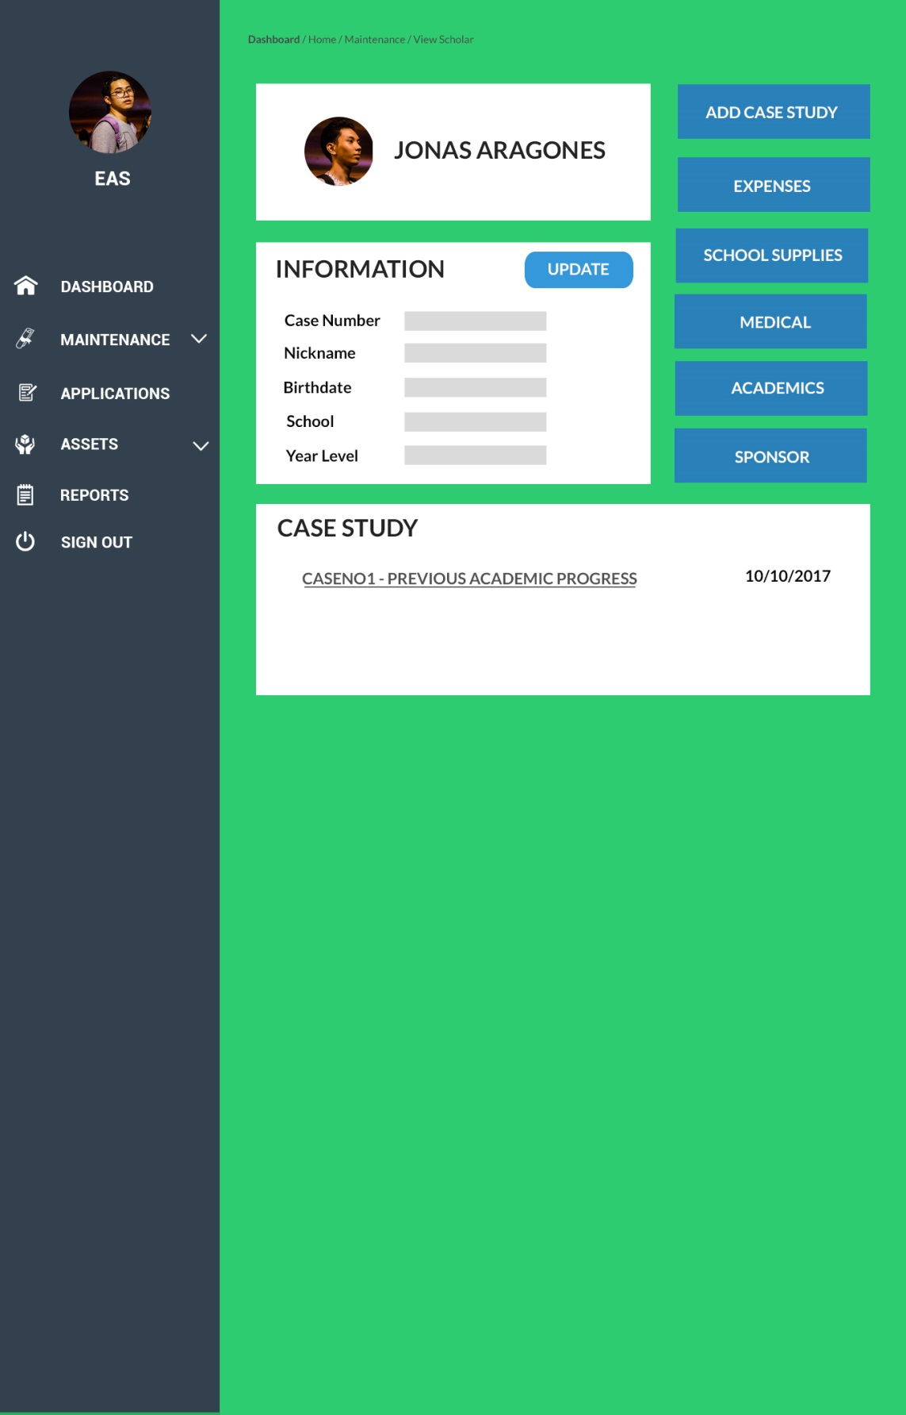

*View Scholar (EAS Staff)*

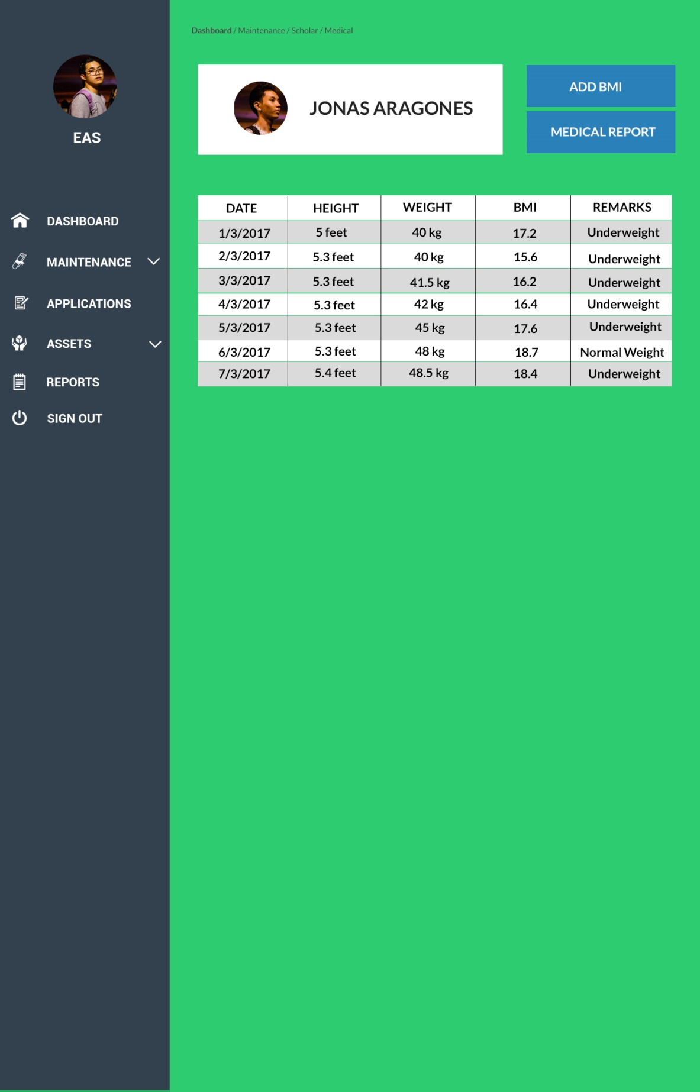

*Scholar Medical (EAS Staff)*

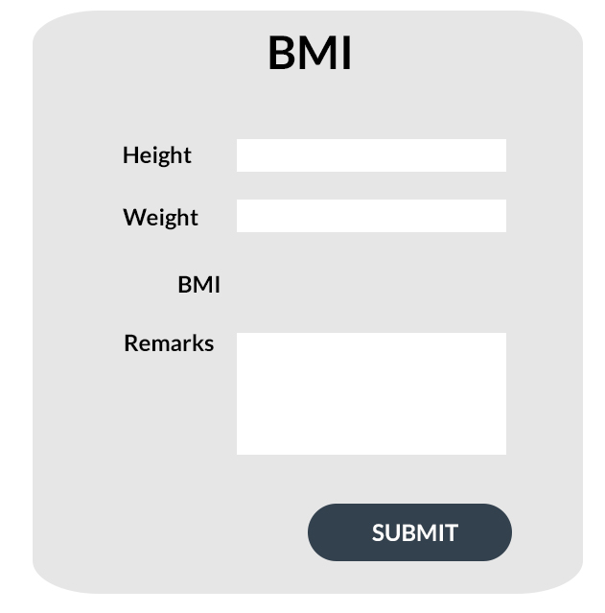

*Add BMI Modal (EAS Staff)*

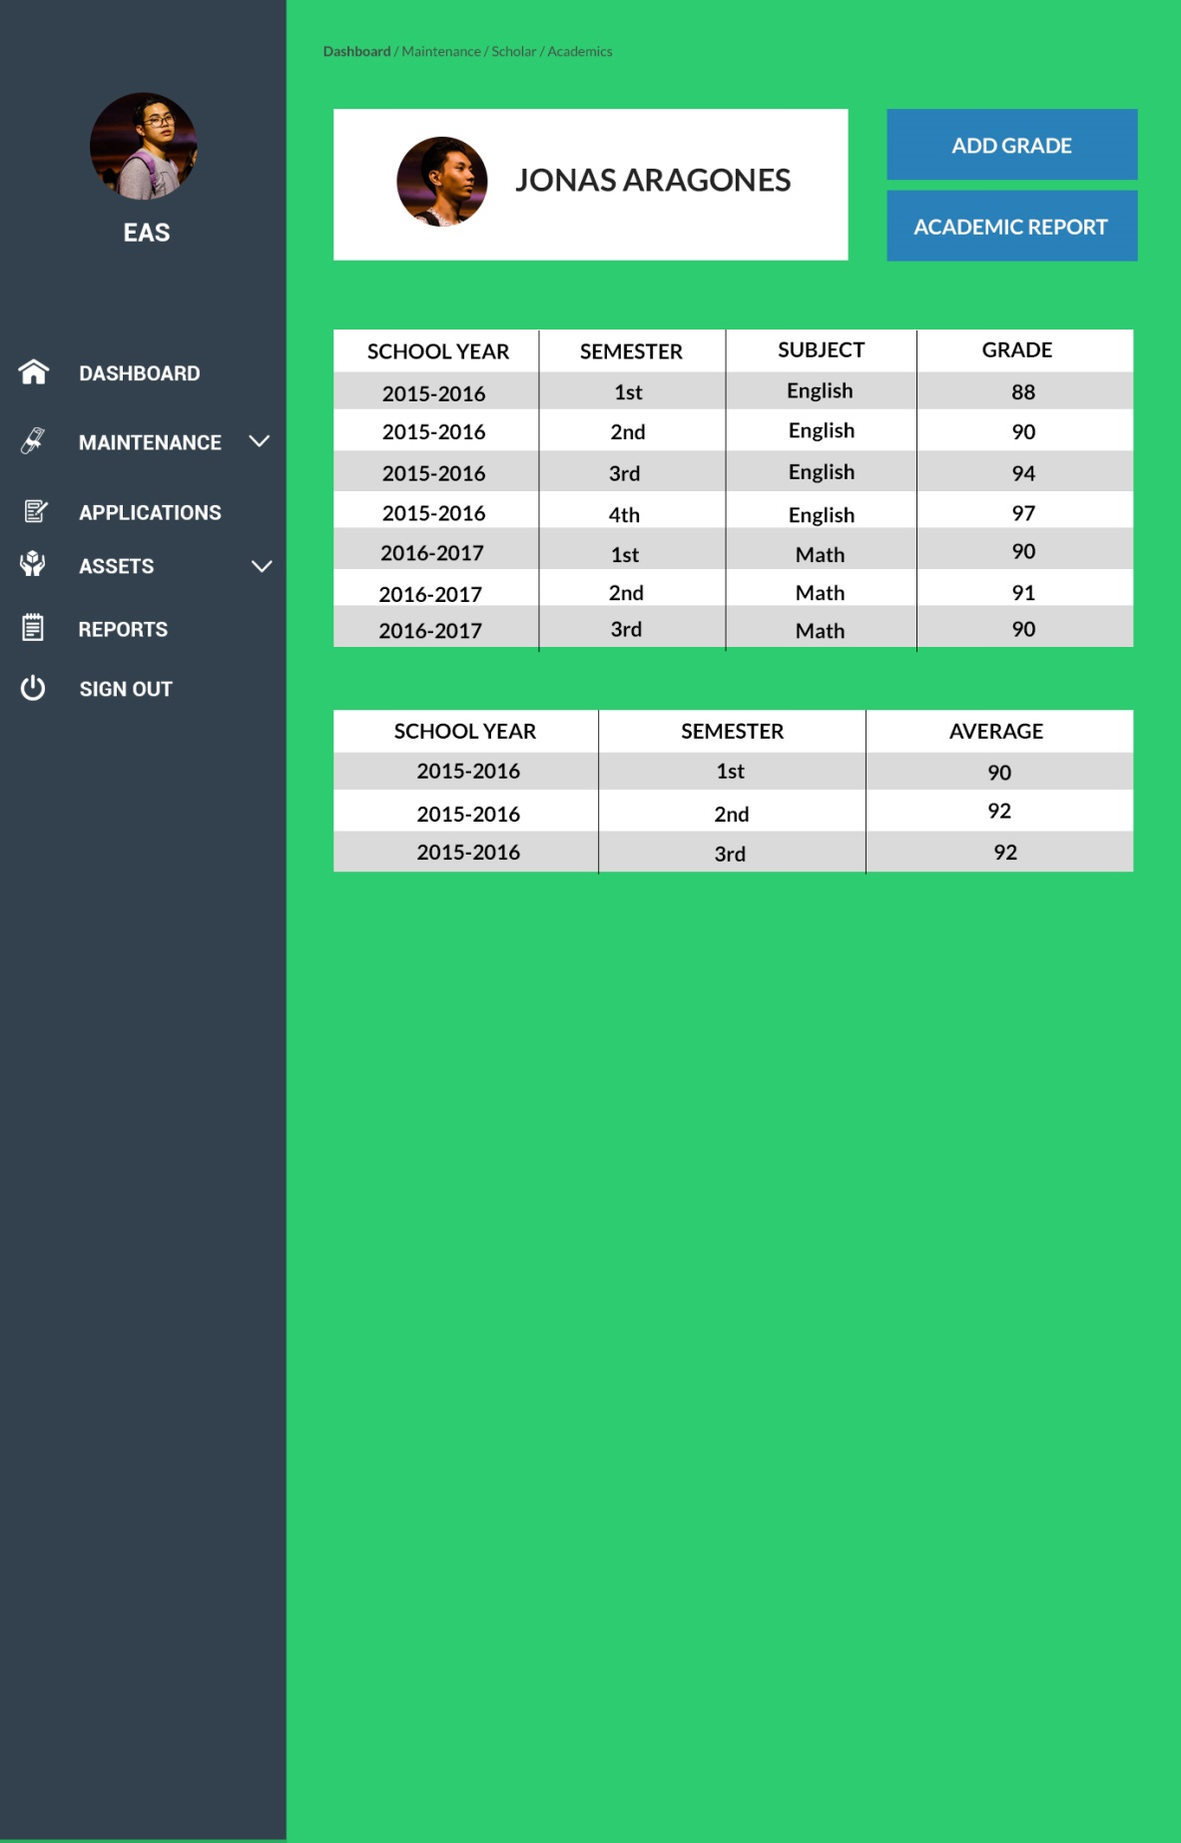

*Scholar Academics (EAS Staff)*

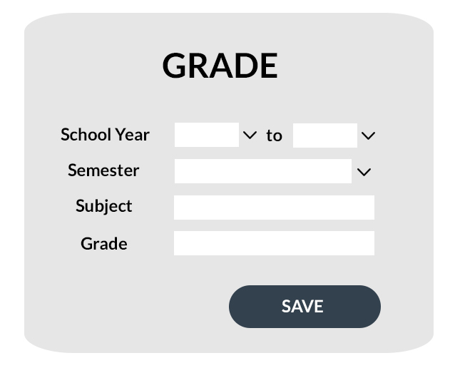

*Add Grade Modal (EAS Staff)*

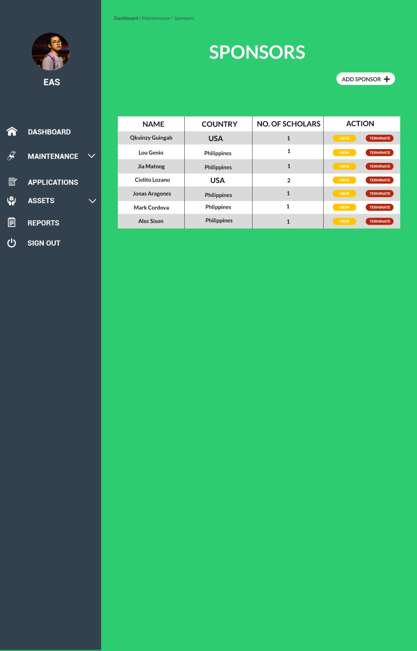

*Sponsor Maintenance (EAS Staff)*

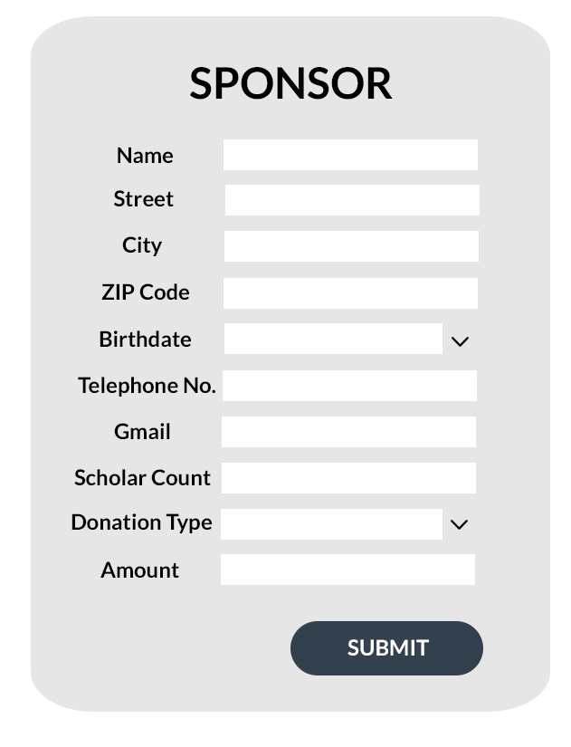

*Add Sponsor Modal (EAS Staff)*

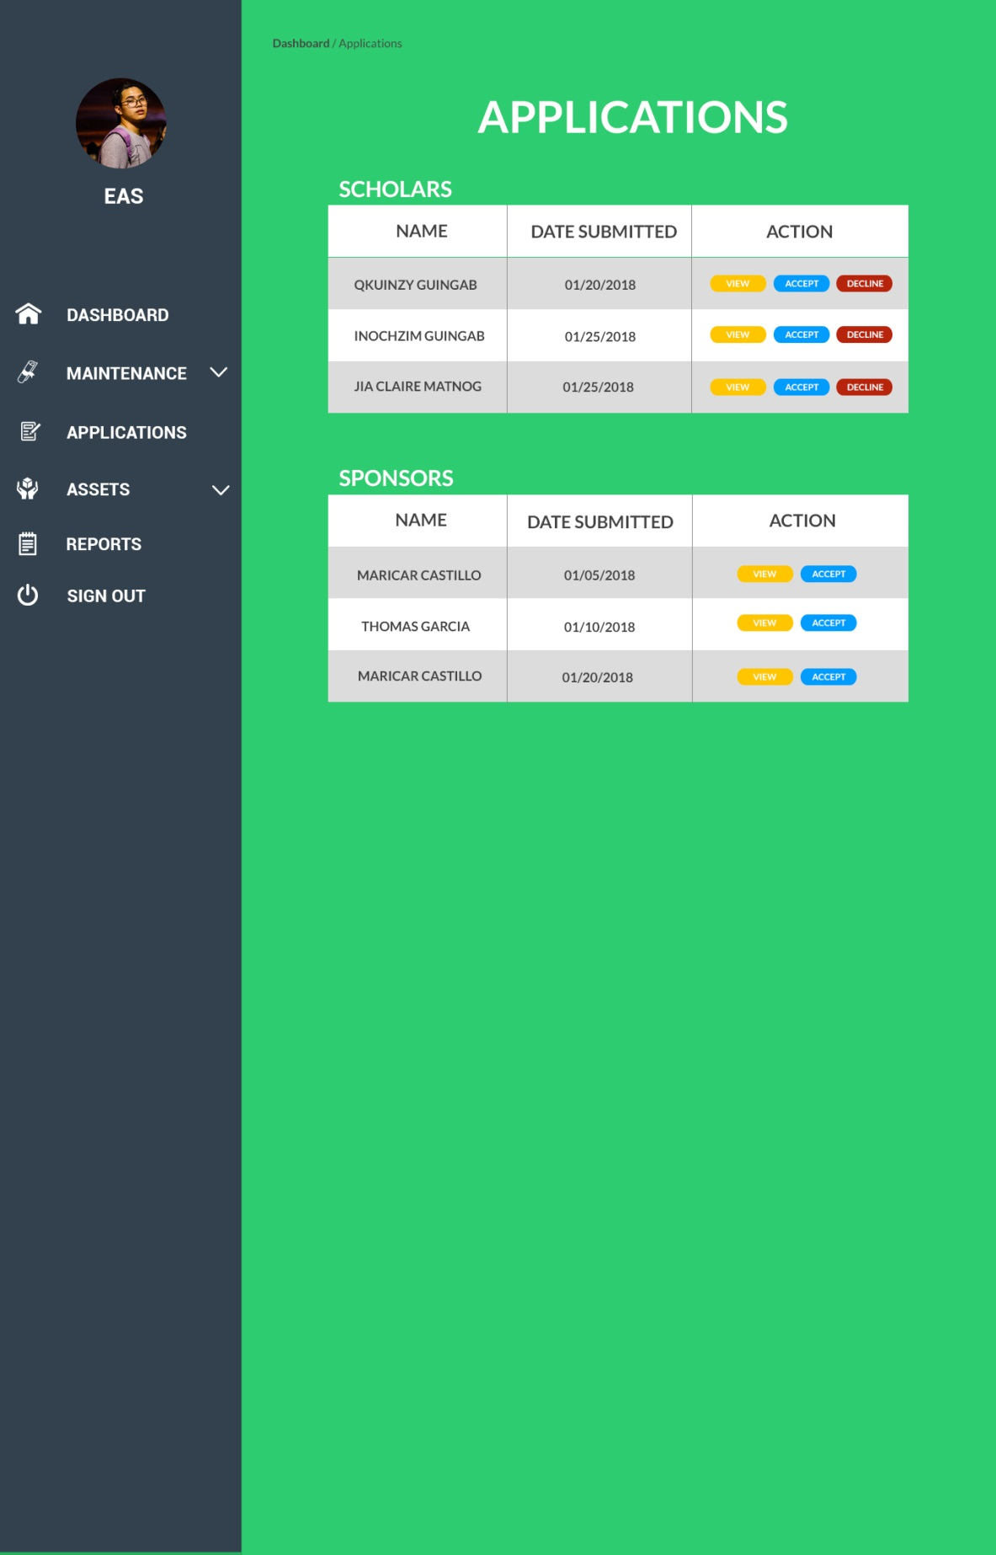

*Application Monitoring (EAS Staff)*

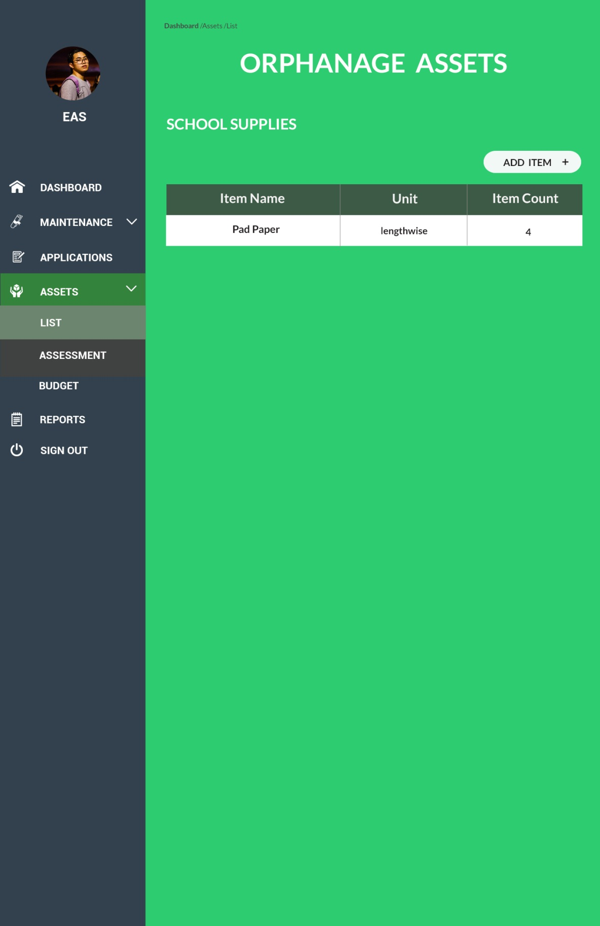

*Orphanage Assets (EAS Staff)*

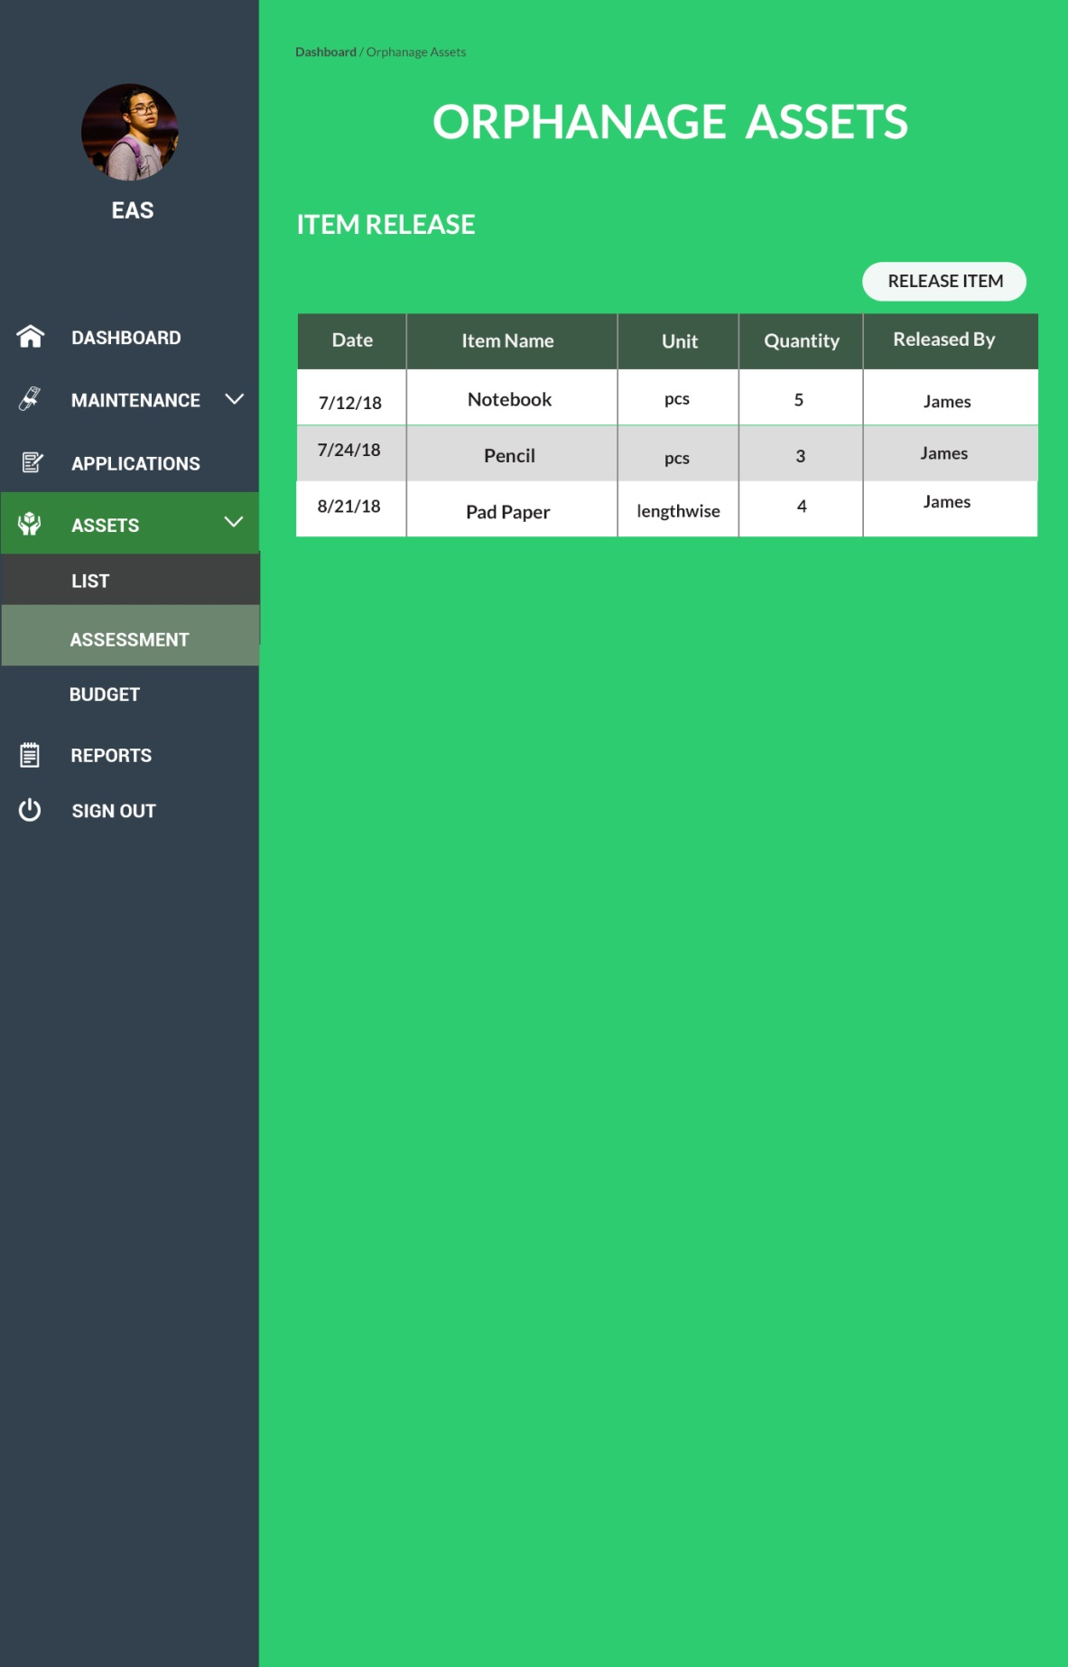

*Item Released (EAS)*

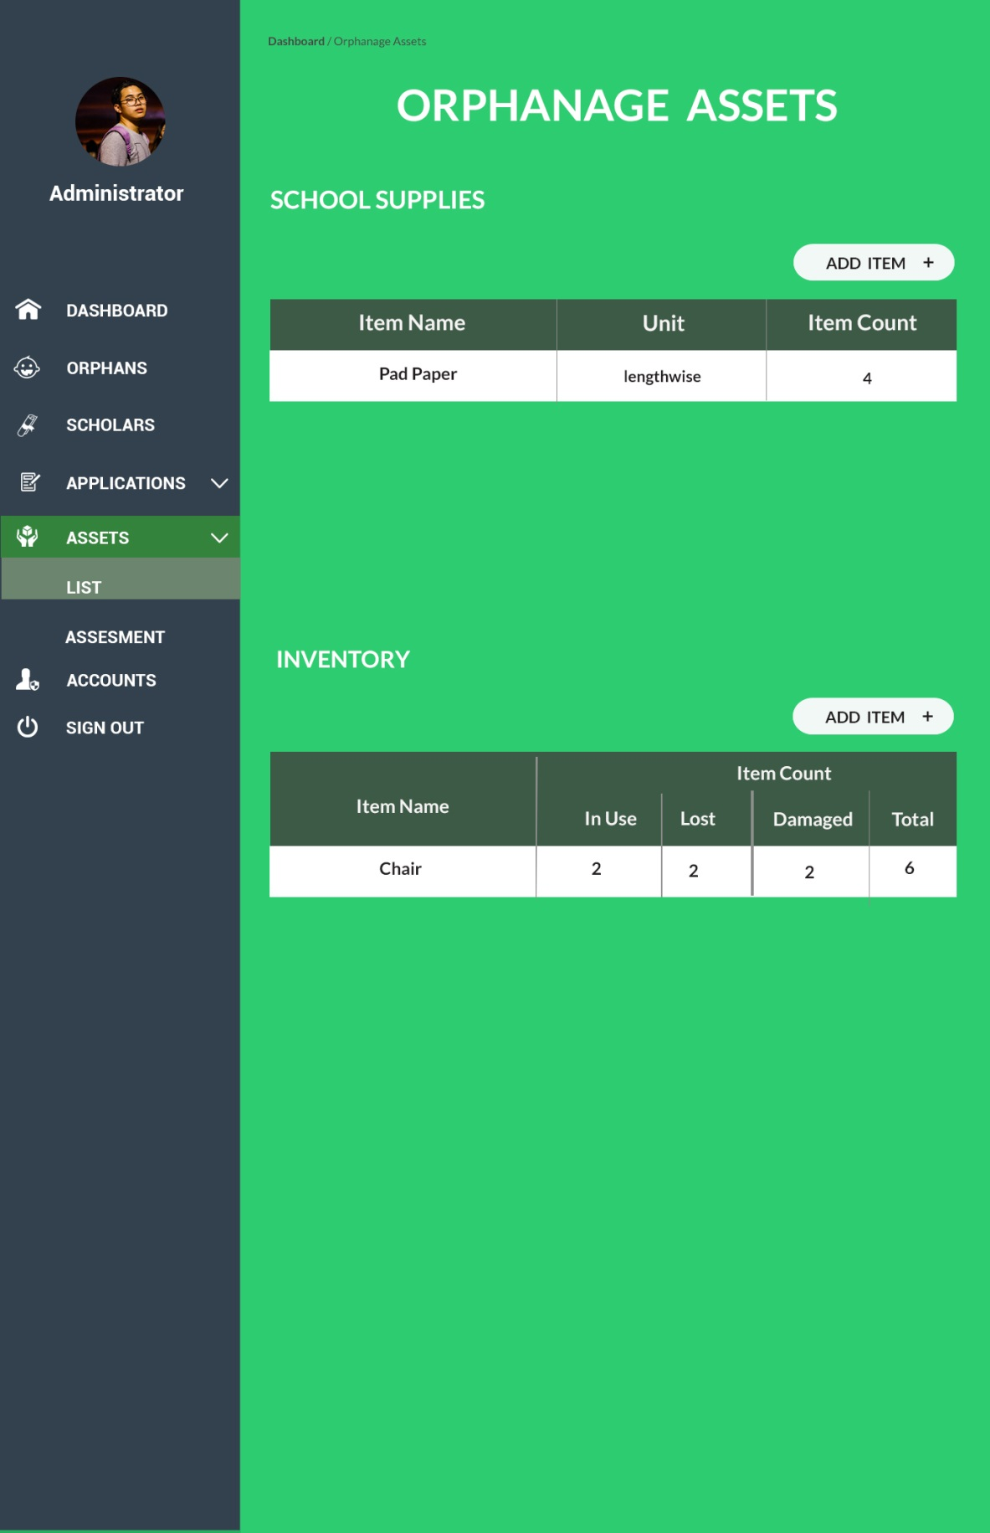

*Orphanage Asset (Admin)*

* + 1. Database Schema

(See paper attached..)

**References**

1. Orphanage. (n.d.) Cambridge Dictionary. Retrieved from https://dictionary.cambridge.org/us/dictionary/english/orphanage
2. Shreya Krishnam, November 23, 2016, Orphanage Management System, https://medium.com/@shreyakrishnam/orphanage-management-system-7d966ca3f419
3. SS Daodu, SC Agu, F Amadin, March 2017, Design and Implementation of web based system for orphanage management, https://www.ajol.info/index.php.jonamp/article.view.127832
4. Eric Irvin Saucer, 2011, Scholarship Management System, http://scholarworks.uni.edu/hpt
5. Noor Hartini Binti Shamsudin, June 2012, School Asset Management System,http://umpir.ump.edu.my/4462/1/CD6526_NOOR_HARTINI_SHAMSUDIN.pdf
6. Cedric Eduard Calapatia, March 2014, Budget Monitoring Application, https://www.scribd.com/document/304987984/Budget-Monitoring-Application-a-thesis
7. Bindu Madhavi K. Khambam and Suganya Srinivasan, 2015,“Budget Planner”,ftp://ftp.ecs.csus.edu/nguyendh/CSC%20230%20Projects/Budget_Planner.pdf
8. Margaret Rouse, May 2016, “Cloud Service”, http://searchstorage.techtarget.com/definition/cloud-storage
9. Bradley Mitchell, September 9, 2017, “Introduction to file storage”, https://www.lifewire.com/introduction-to-cloud-storage-818003

# **Appendices**

Data Flow Diagram